Continuous Assessment – 2

CSE -427

# VIRTUALIZATION AND CLOUD COMPUTING LABORATORY

Name : Routhu Siddhartha

Reg. No. : 12010599

Section : K20CT

Group : 2

Roll No. : RK20CTB51

Course code : CSE427

Task : Continuous Assessment 2

Date : 23-02-2023

Under the guidance of

AJAY KUMAR BADHAN Sir,

(27337).



**Task 1 : Creating the Virtual machine on HOL and install the photon OS.**

Open any of your favorite browser and search for HOL. Click on the first link which is from vmWare Hands on Lab.

Search forVirtualization 101 (HOL-2210-01-SDC) and then enrol for it. Now start the Lab.

This is the interface of the Hands On Labs Virtual Machine  
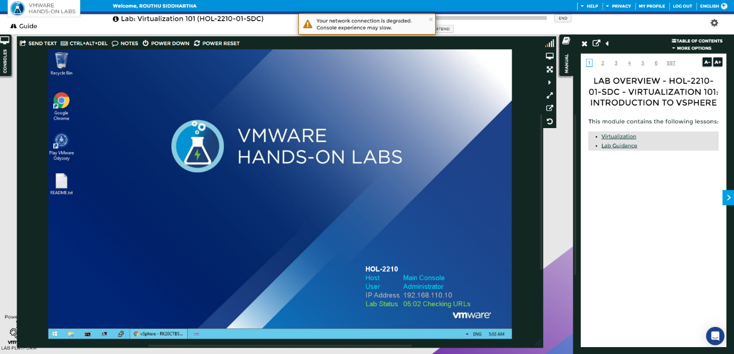

1. Now we need to open the chrome software from the HOL.  
   And click on **vSphere Web Client** from the bar

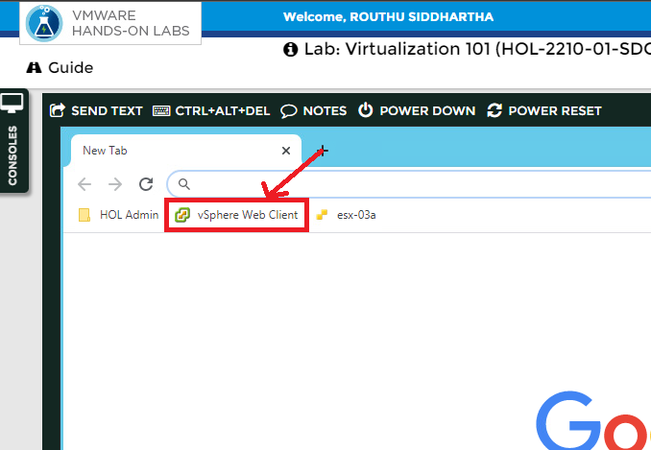

Selecting Use Windows session authentication check box and click on Login

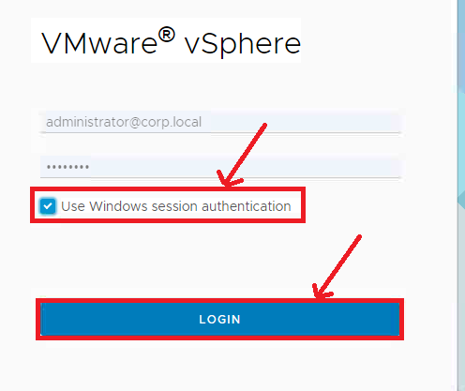

This is the interface of the vSphere Client.

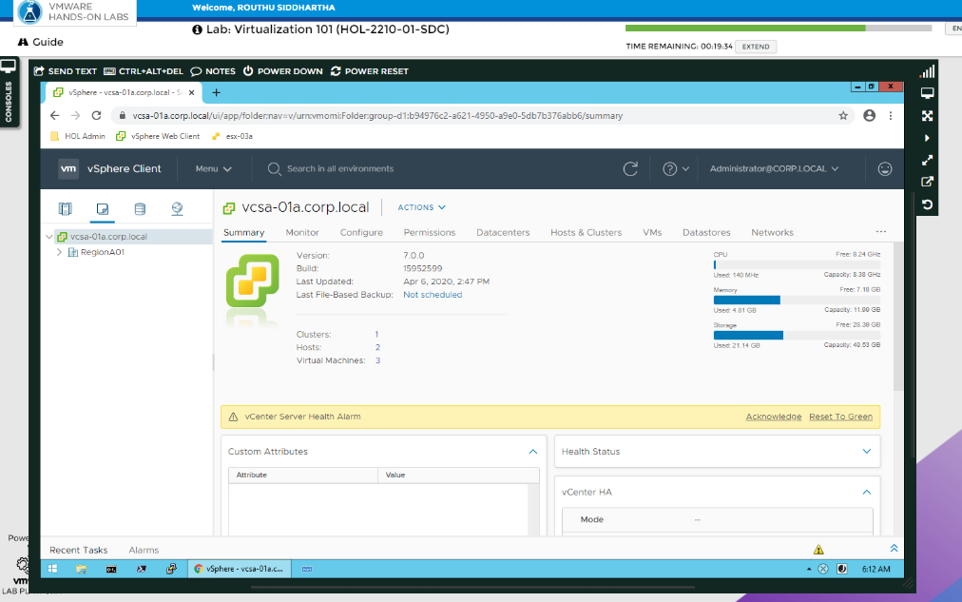

To create the new virtual machine, we need to click on the menu option and than choose VMs and Templates

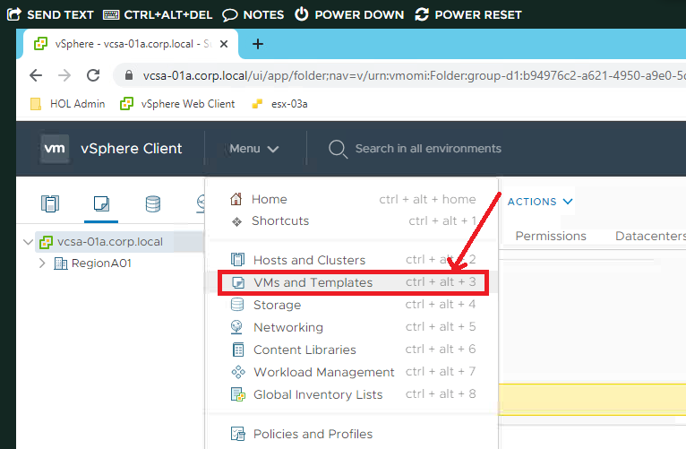

Now we need to right click on RegionA01 and select the New virtual machine option

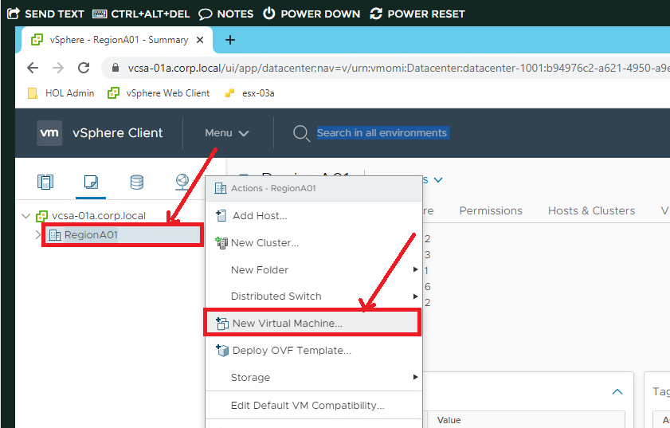

Now we need to choose Create a new virtual machine option. Click on Next

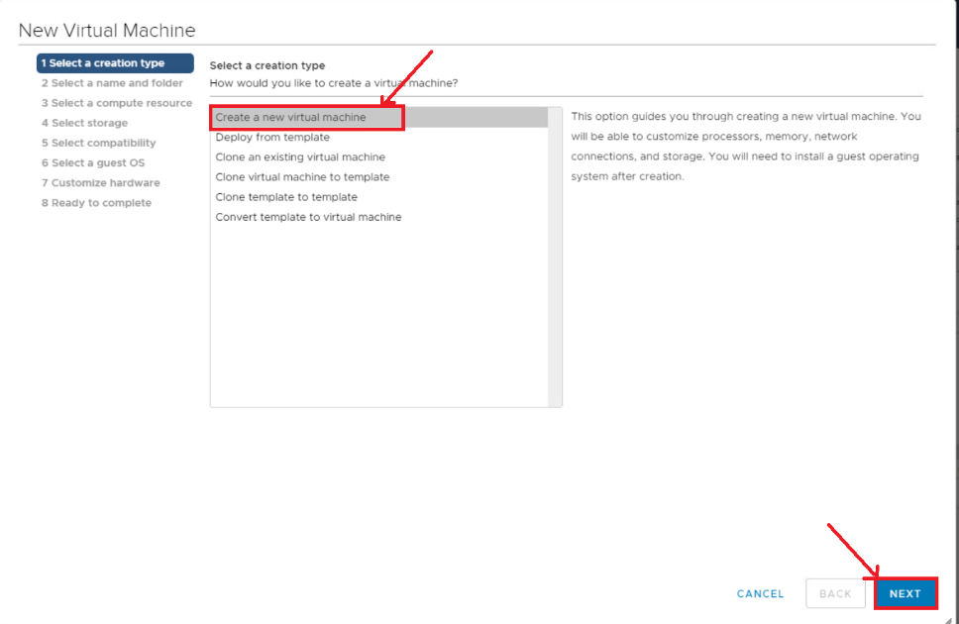

Giving the name for the virtual machine. Click on the Next button.

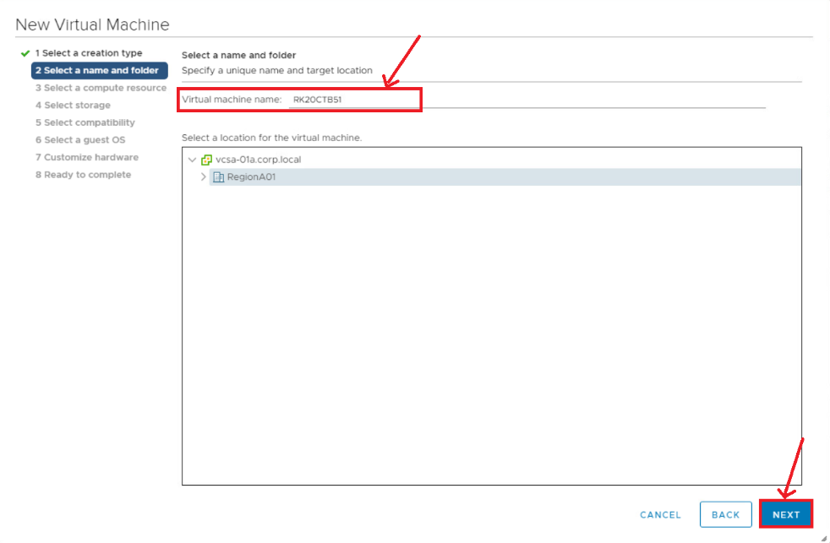

Now, we need to select esx-O1a.corp.local and than click on Next.

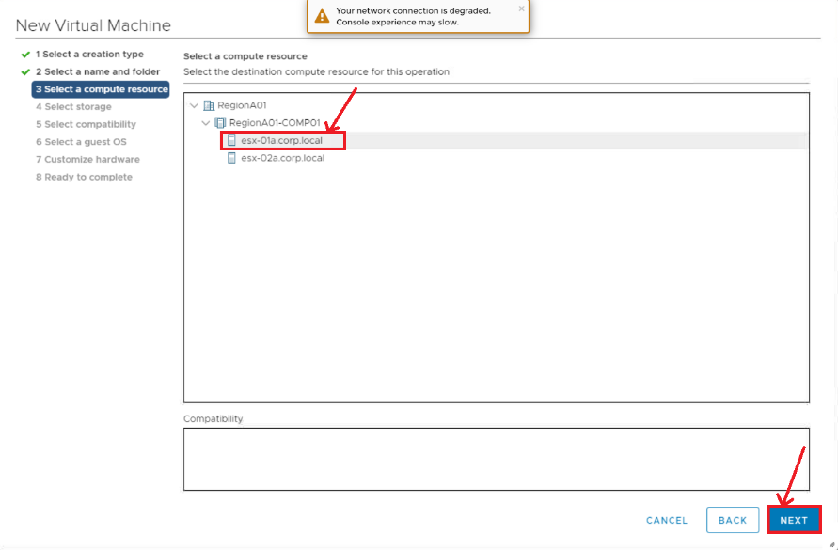

Now, we need to select ds-IscsI01 option. Click on next.

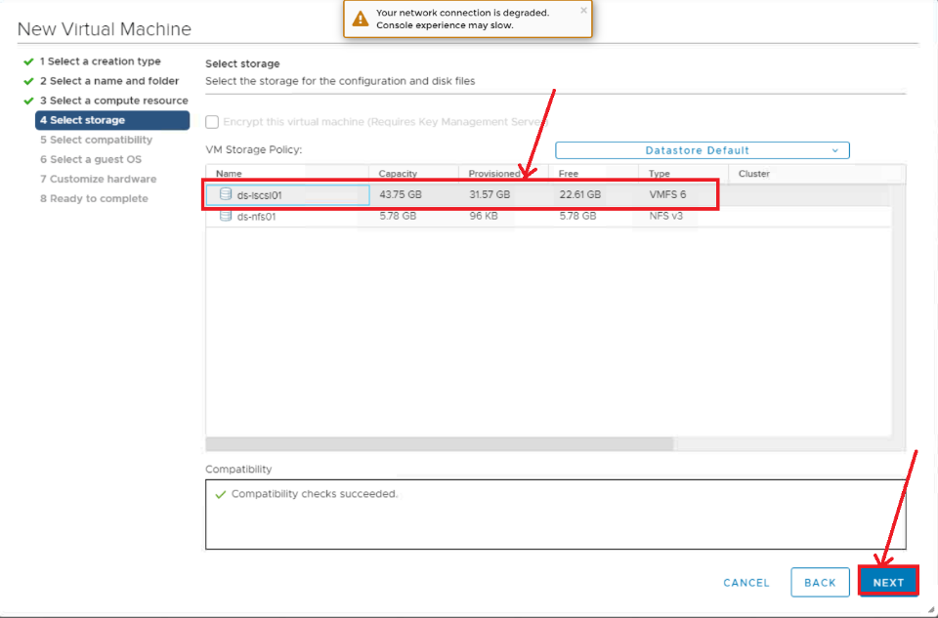

Now, selecting Esxi 7.0 and later for better efficiency. Click on Next.

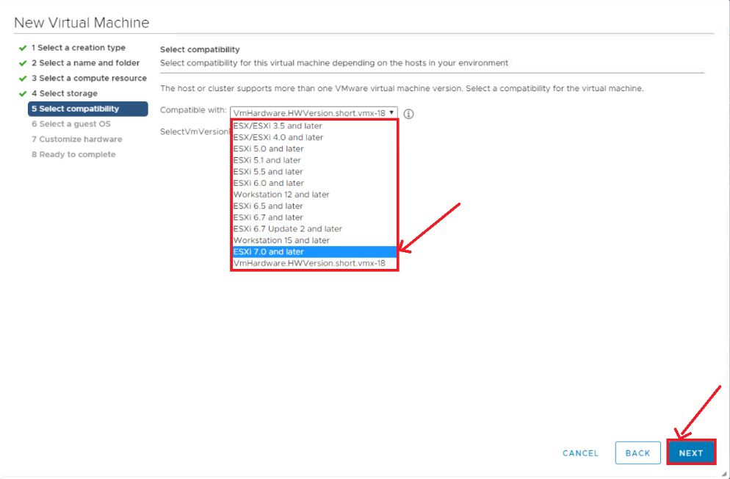

Now, we are going to select the operating system. Here, we select the LINUX VMware photon OS(64 bit). And click on Next.

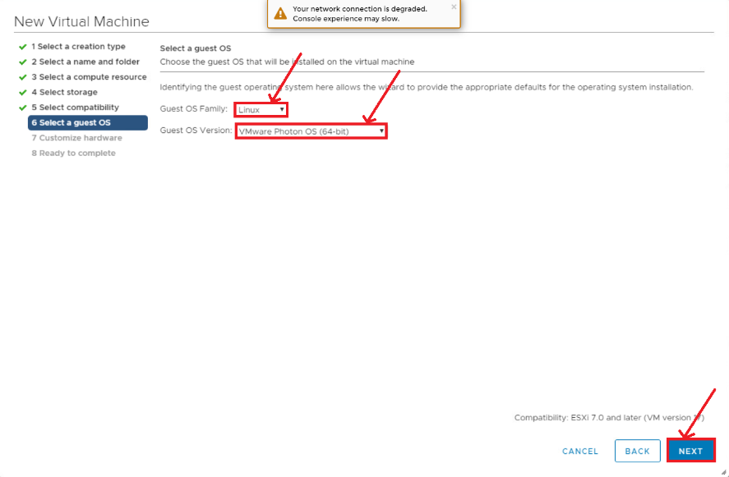

Confirming the requirements of the operating system and click on Next.

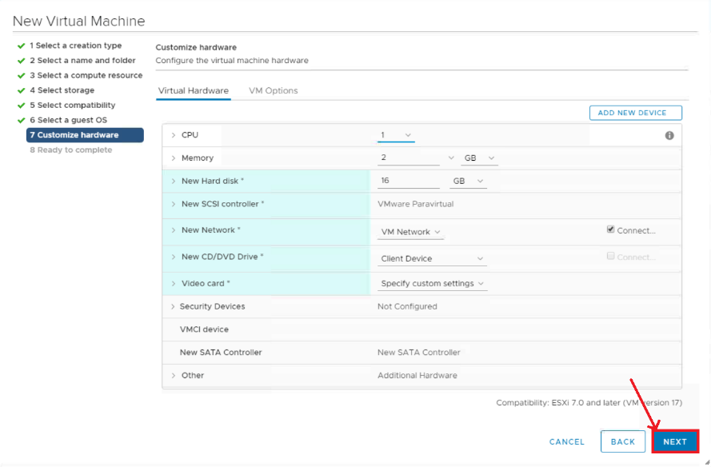

Click on Finish after checking all the details.

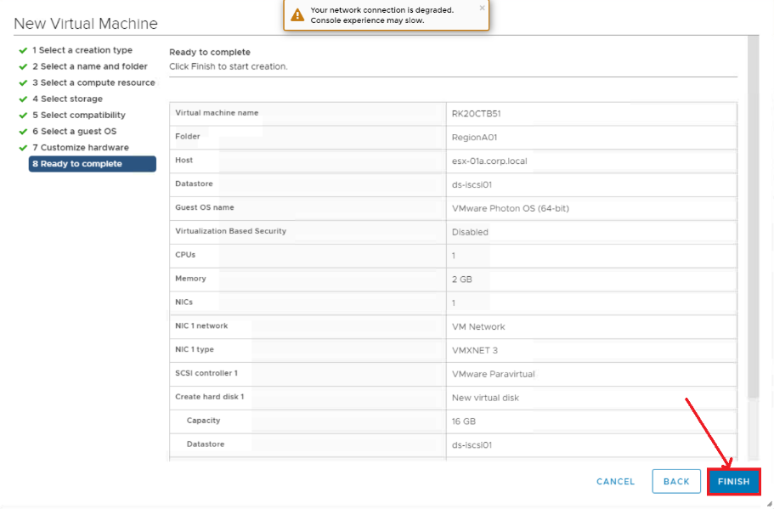

Now we created VM environment for the following operating system. Now we need to install the OS

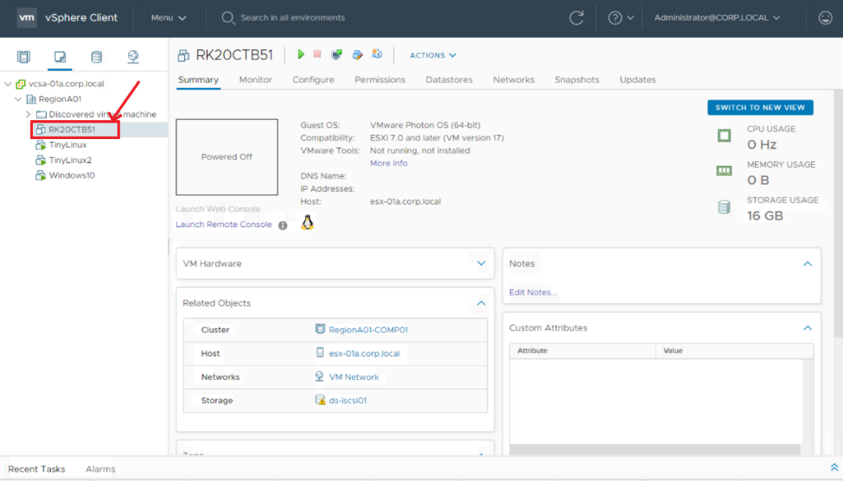

Right click on the OS which was created and select Edit Settings option

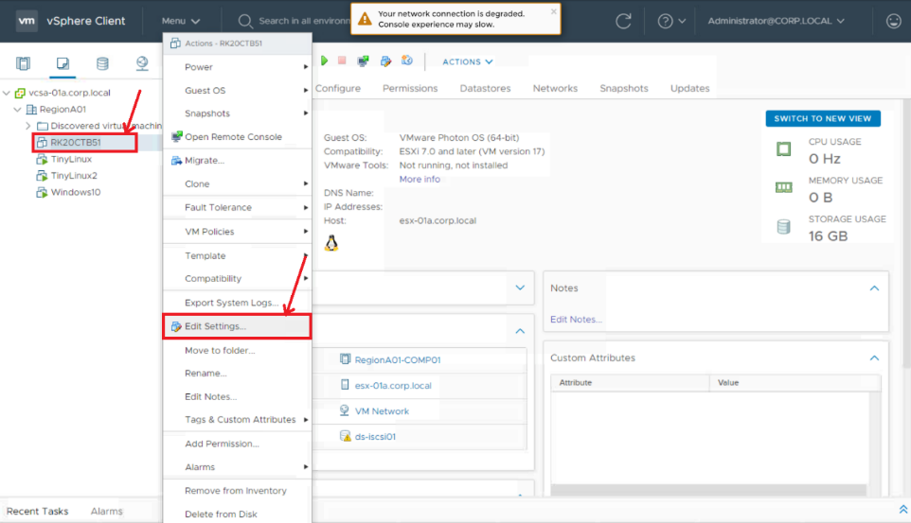

Under CD/DVD drive 1 section select content Library ISO file. And click on OK

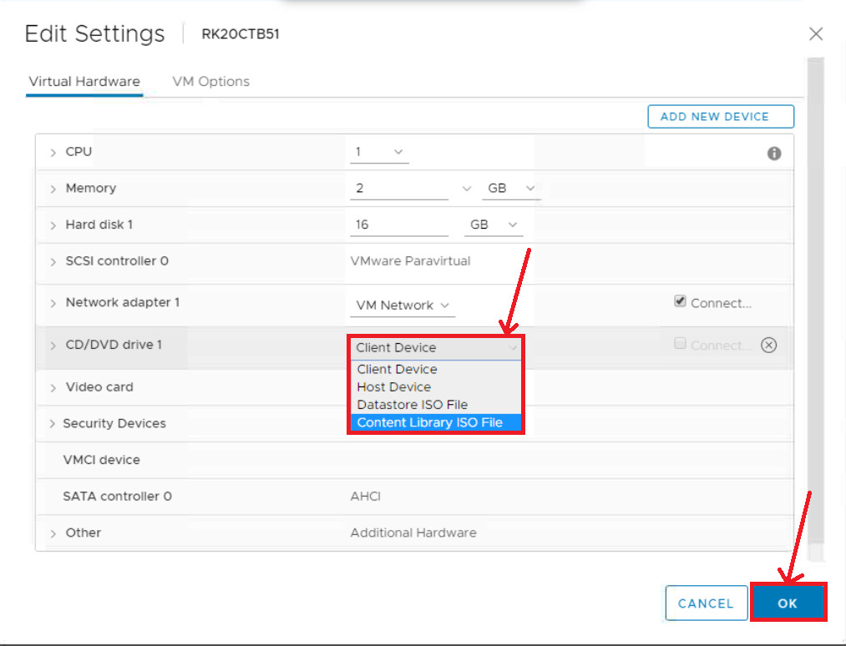

Choose photon as a ISO image to mount. Click on OK

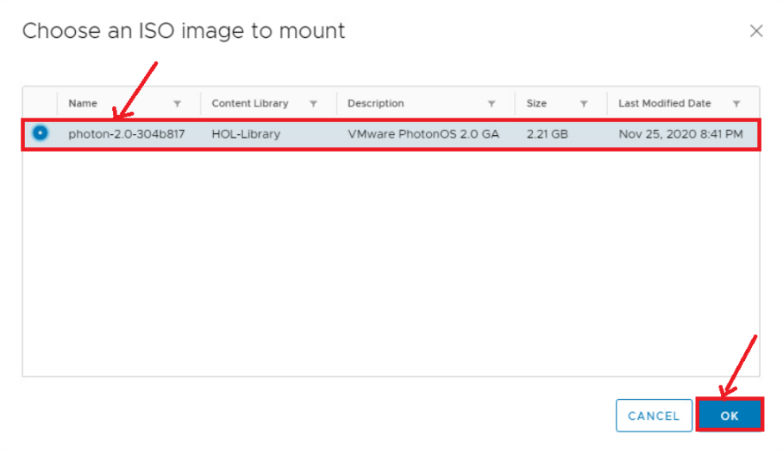

Connecting the ISO file which was mounted. Click on OK

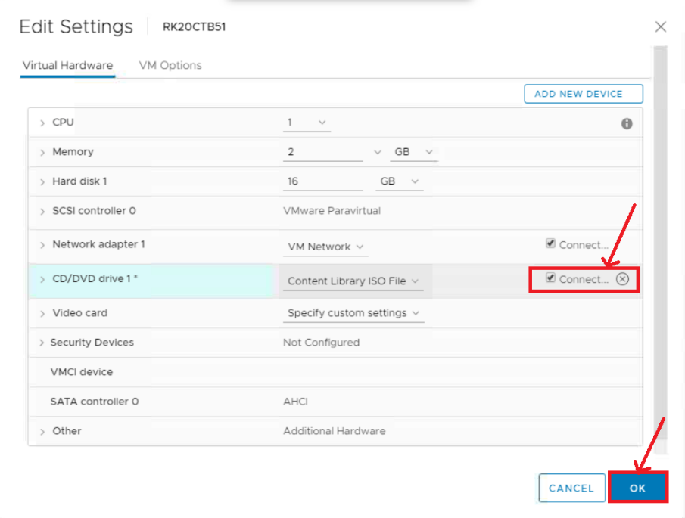

Now power ON the VM to install the OS in the VM

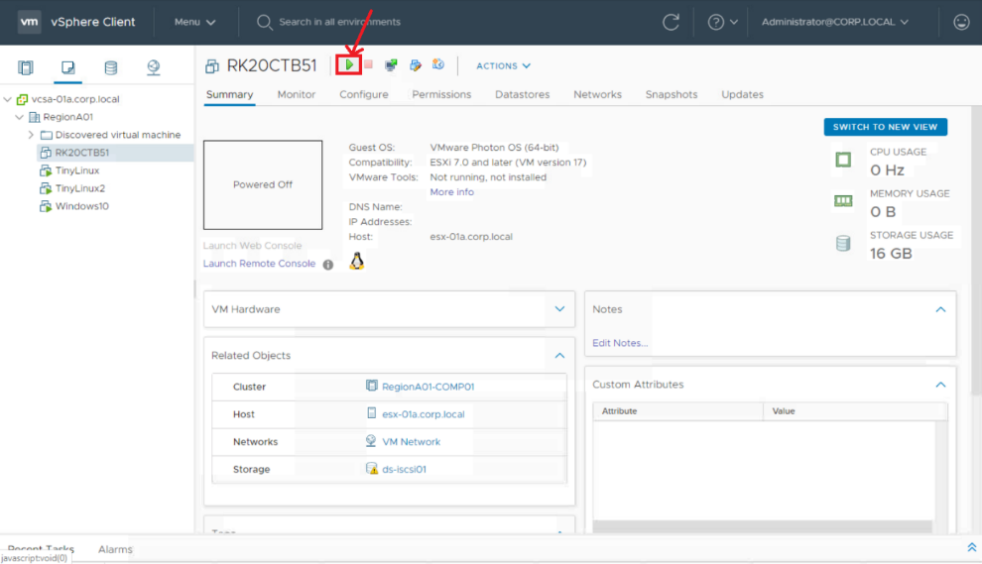

After checking details click on vmware box to get started

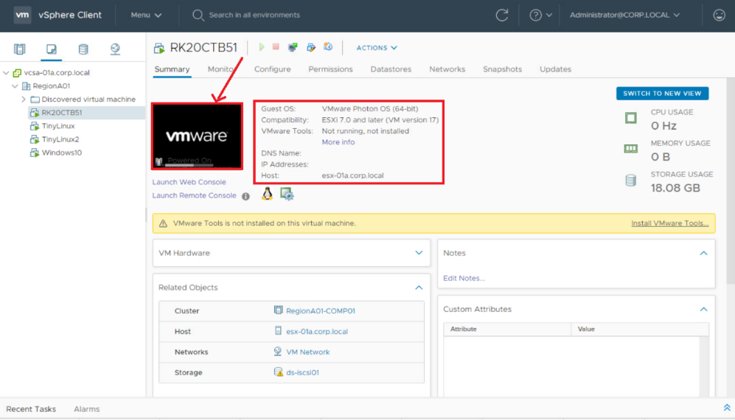

Selecting web console option and click on OK.

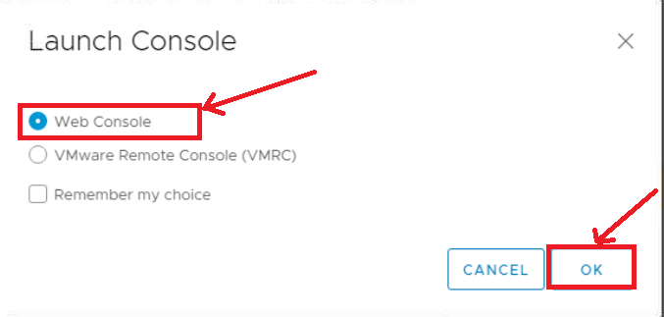

Now installation process get started

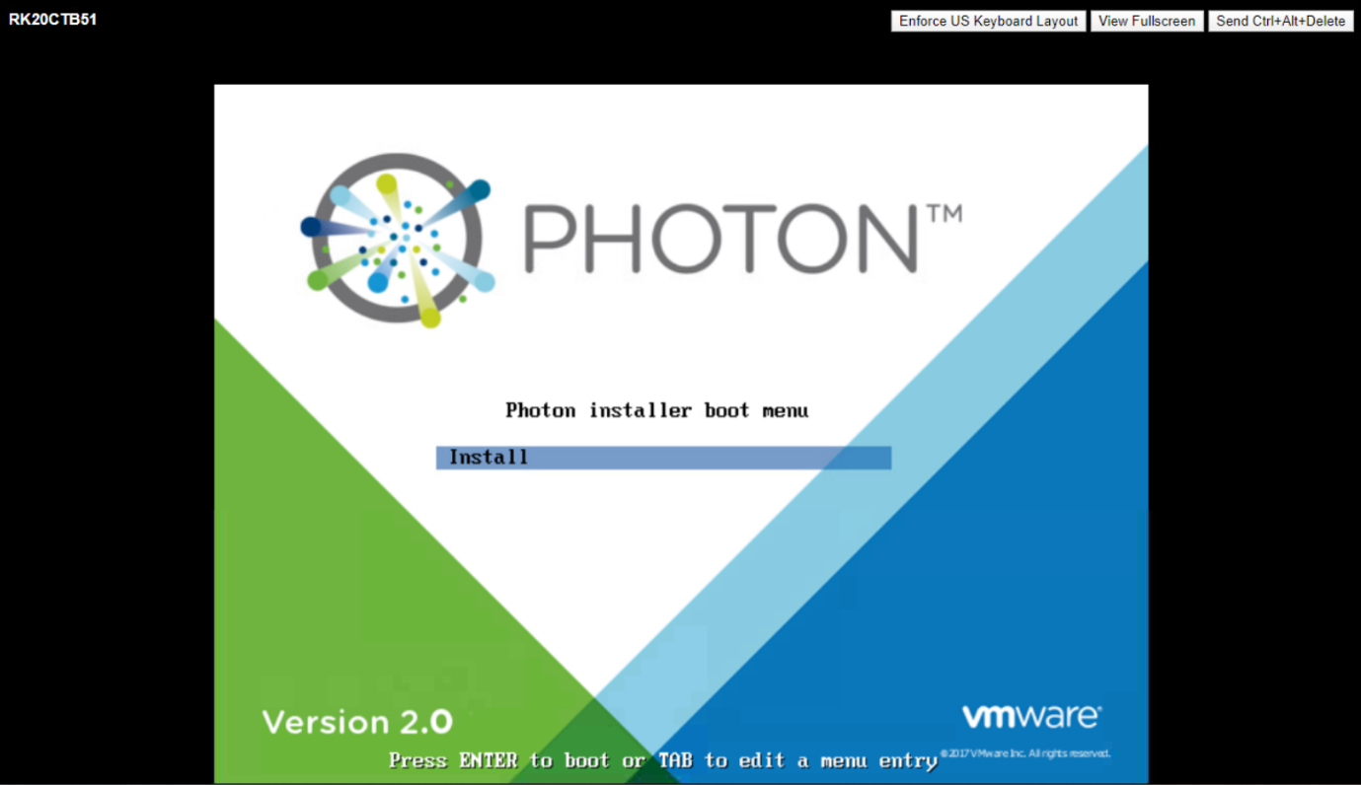

Accept the Agreement by clicking on enter button.

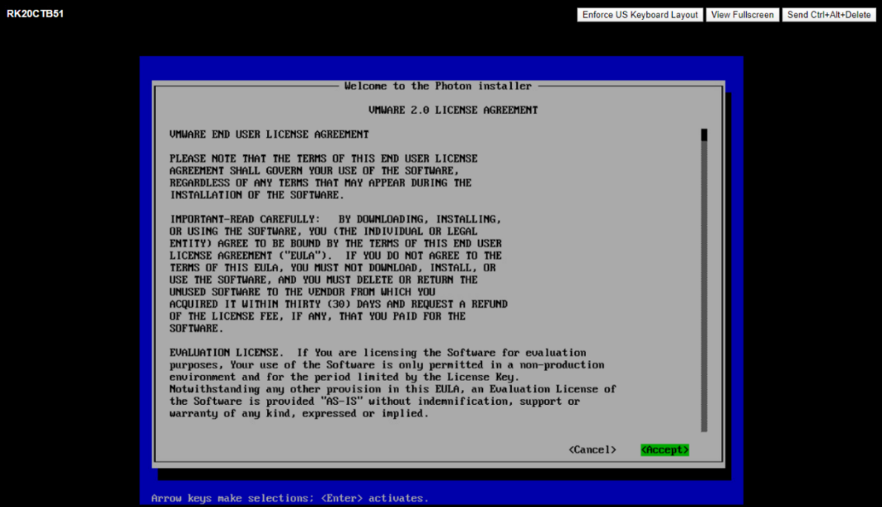

Disk was already selected. So, just we need to click on Enter button on Keyboard.

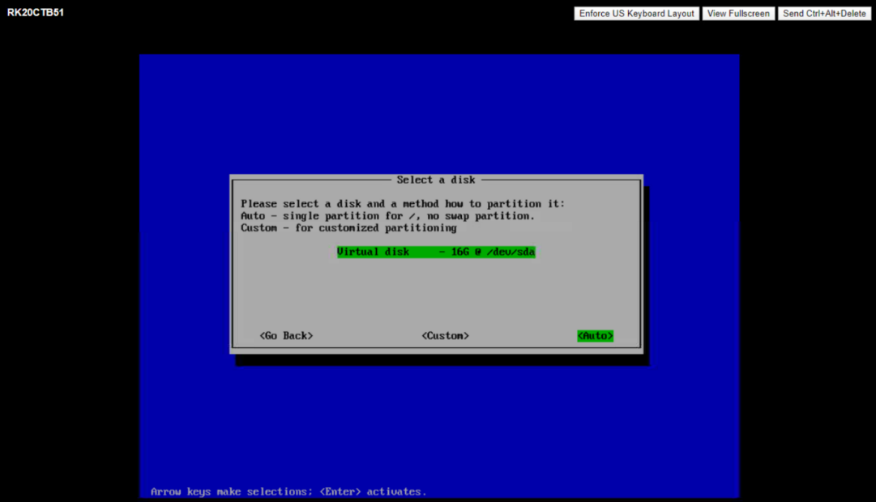

Again, click on enter button.

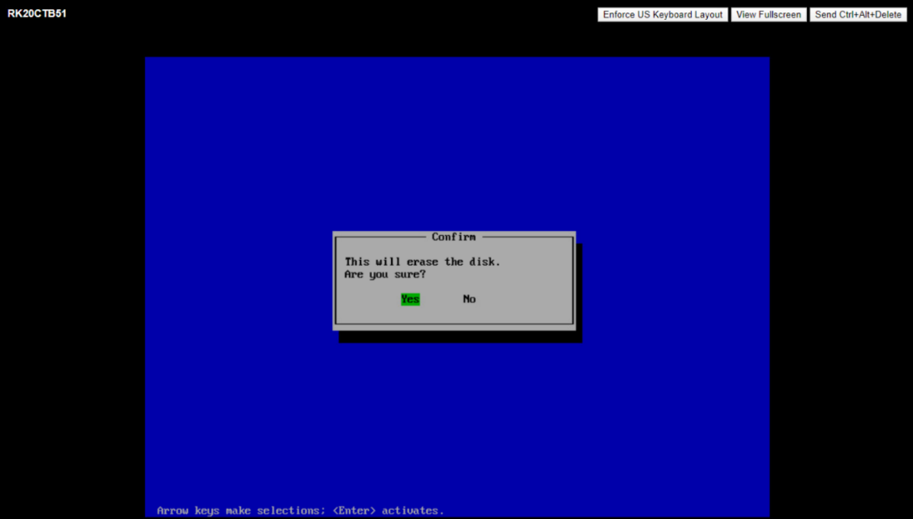

Photon Minimal was already selected. Click on enter button.

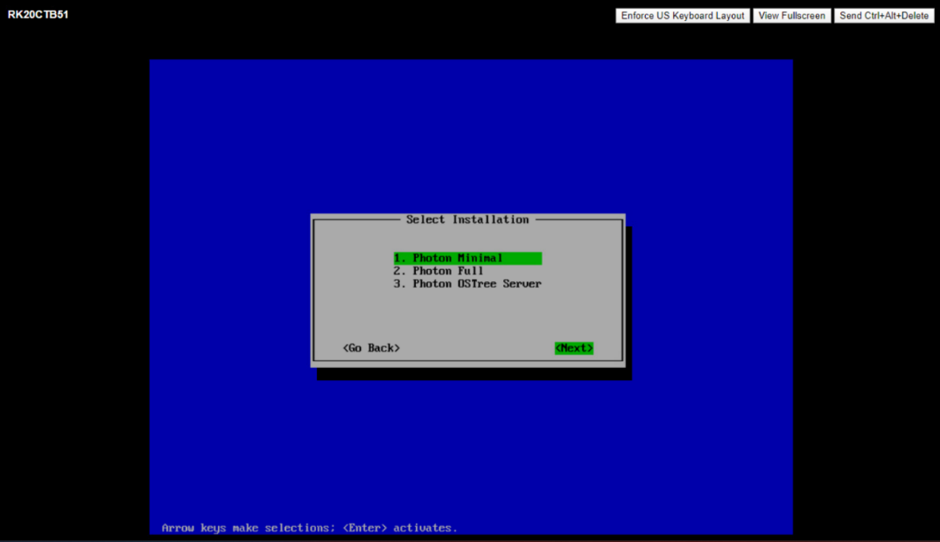

Hypervisor optimized option was already selected. Now click on Next button.

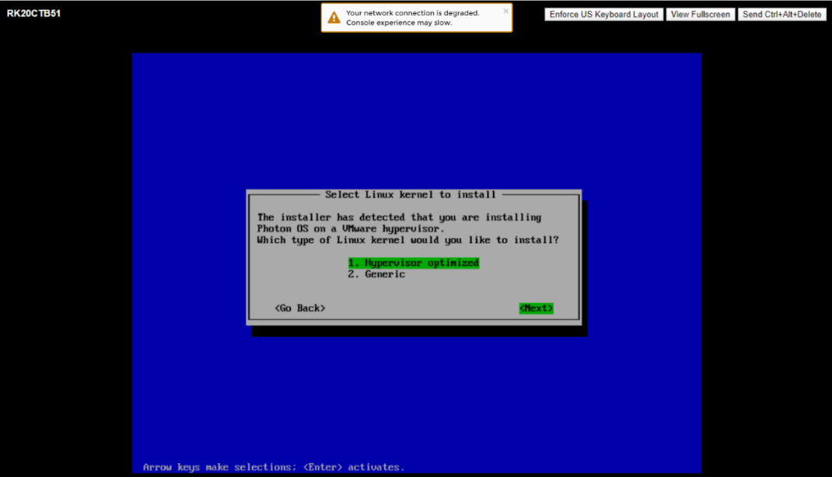

Hostname was already selected. So, click on Next.

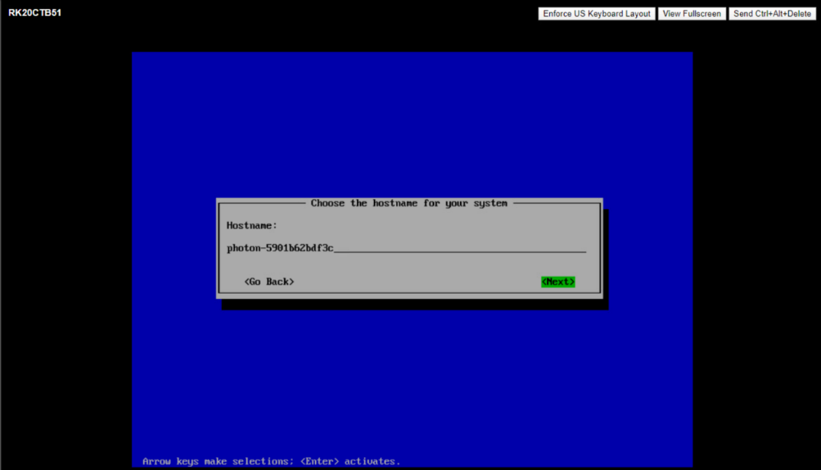

Entering the password. By default the password was VMware1!VMware1!

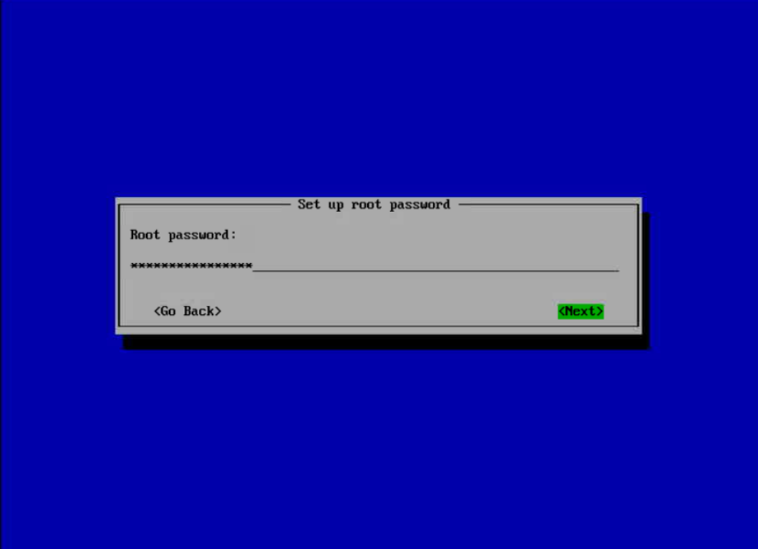

Confirm the same password again and click on next by hitting on enter button.

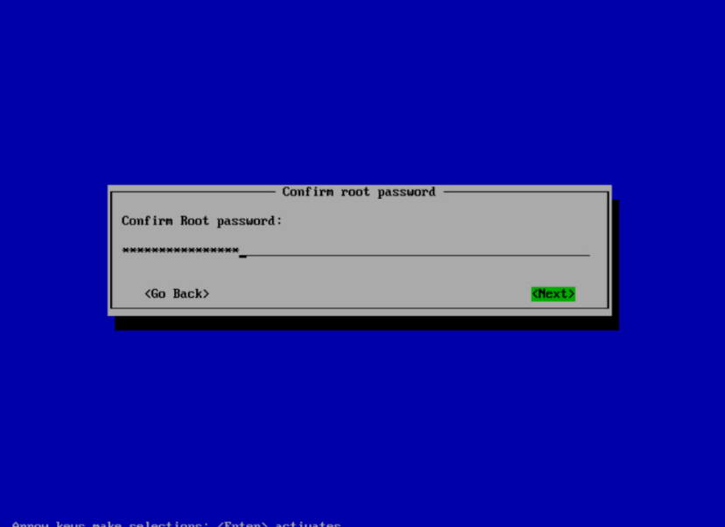

Now the OS get started installing

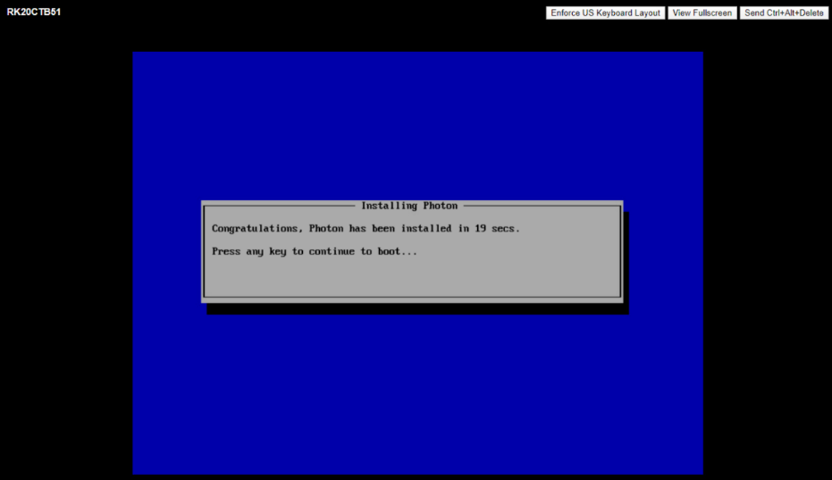

This is the Terminal interface of the OS

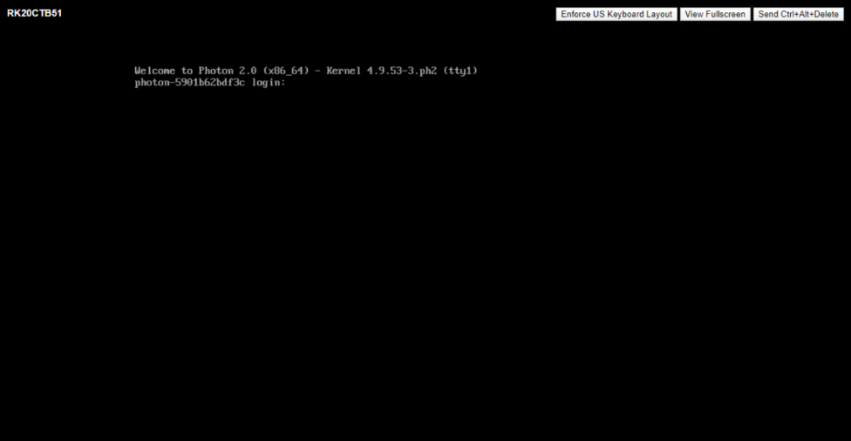

This is the final Interface after the OS got installed.

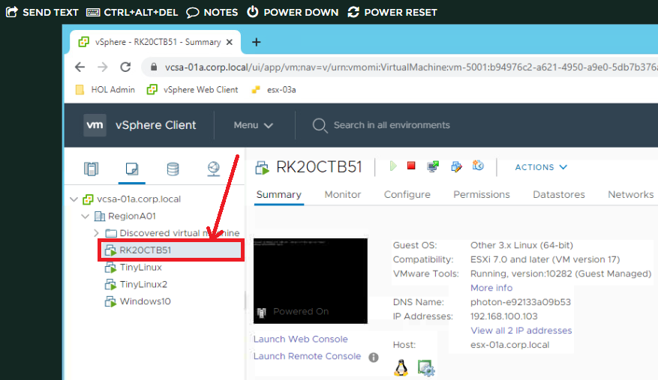

**Task 2 : Cloning the Virtual machine using template mode**

Click on Menu option. Then select VMs and Tamplates

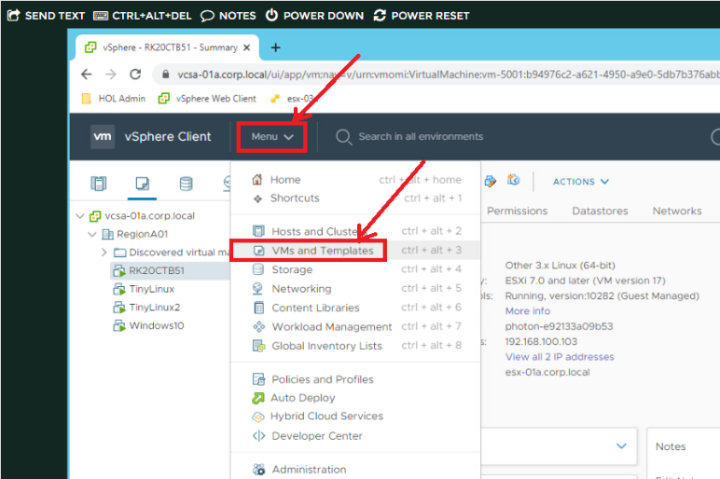

Right click on Created OS. Select Clone option. Then, click on clone to template.

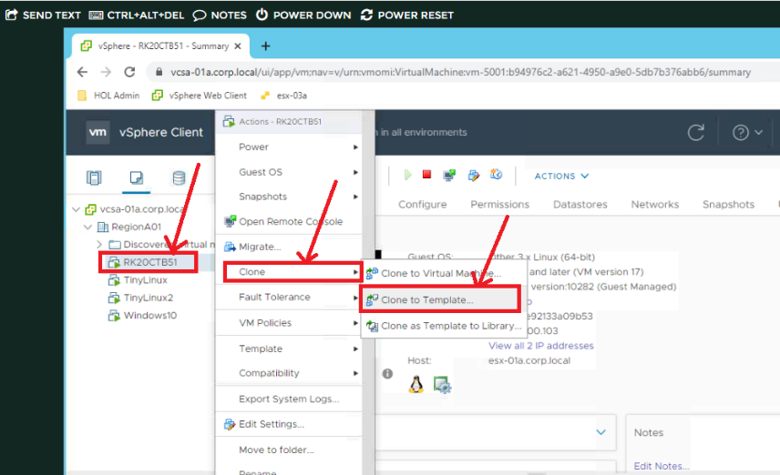

Name the Template accordingly.

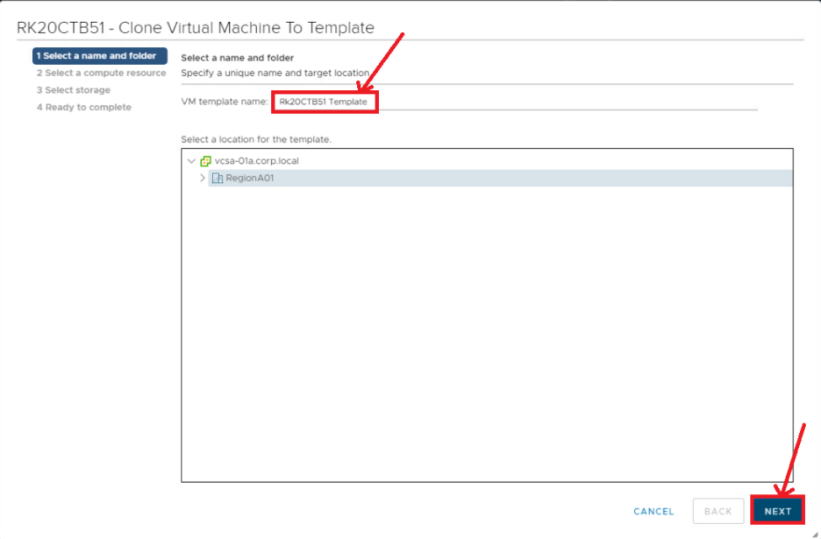

Wee need to select esx-O1a.corp.local . then click on next button

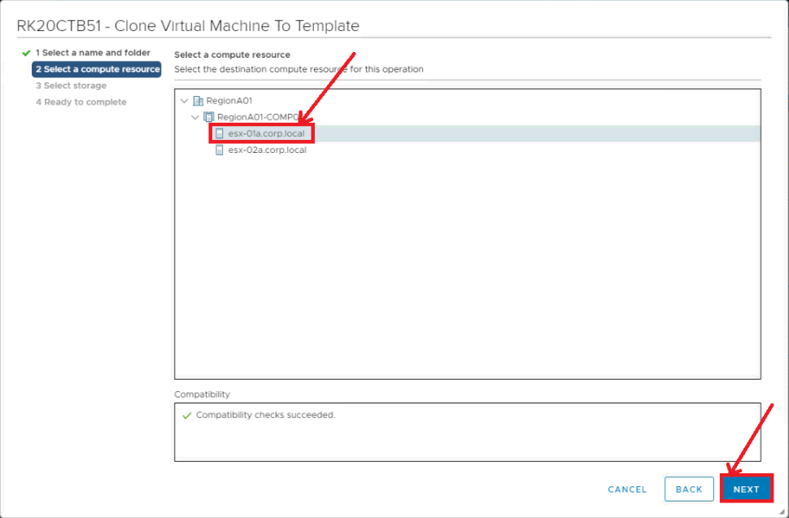

We need to select ds-iscsi01 as it is having the space. Click on Next.

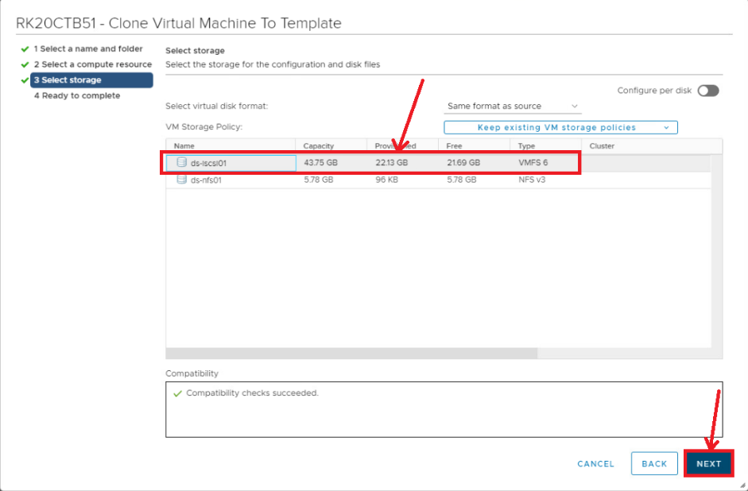

Now, we need to click on Finish button after checking requirements

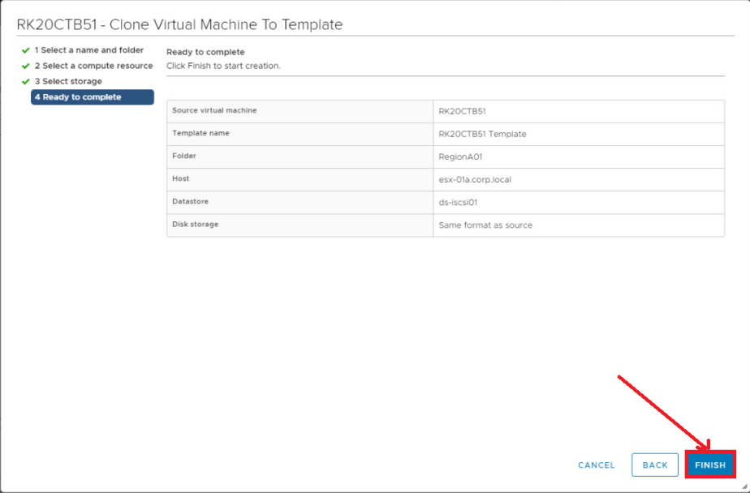

This is the interface which shows the added template

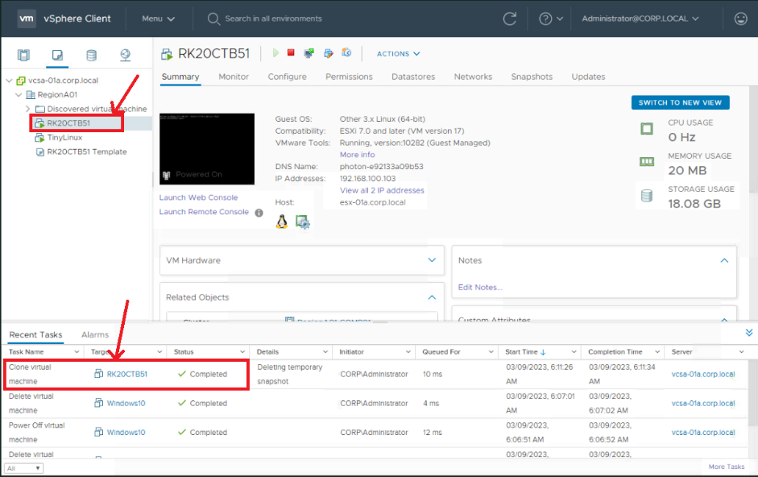

**Deploying the new Virtual Machine from the Template**

Right click on the template created. Then click on New VM from the Template

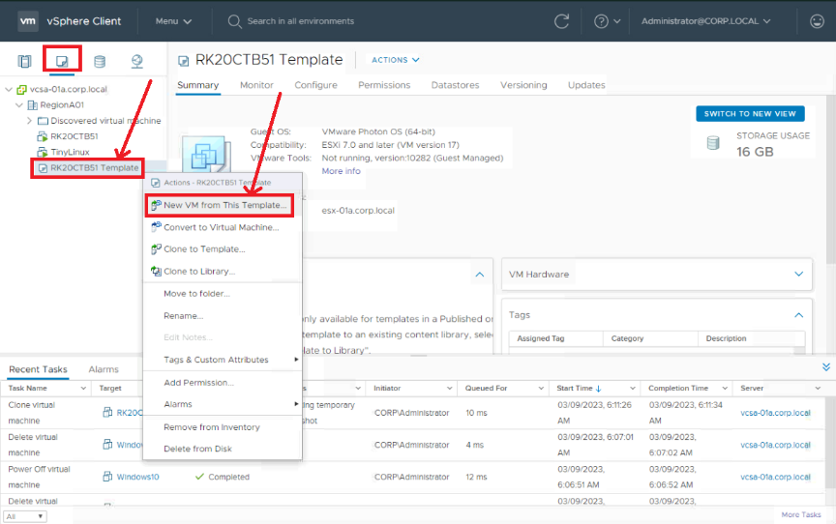

Name the Cloning Template which we are deploying from template.

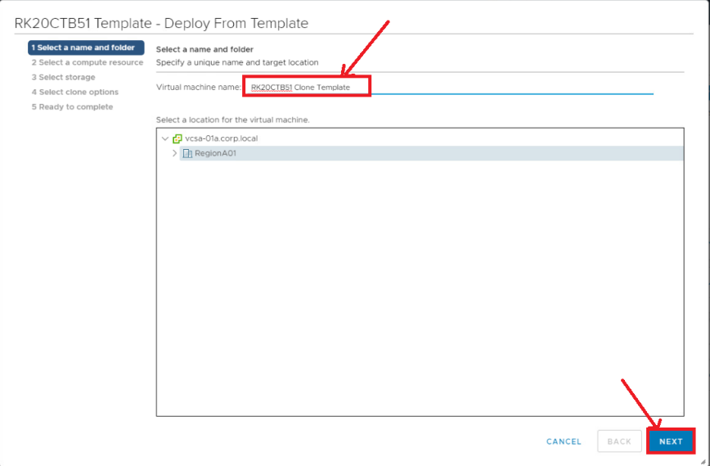

Click on esx-O1a.corp.local . Then click on Next button

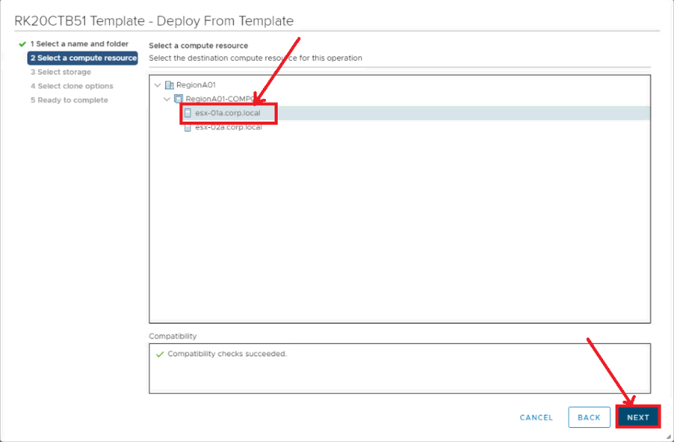

Select the disk for storage. We choose ds.IscsI01. And then click on Next button.

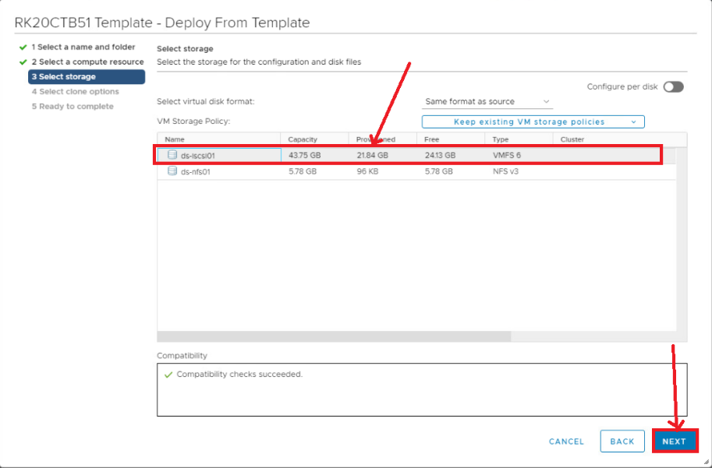

Don’t choose anything just click on Next.

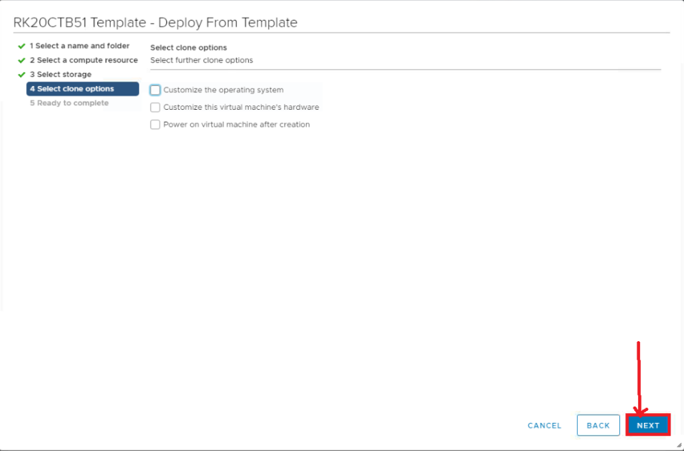

Select esx-O1a.corp.local and then click on Next button.

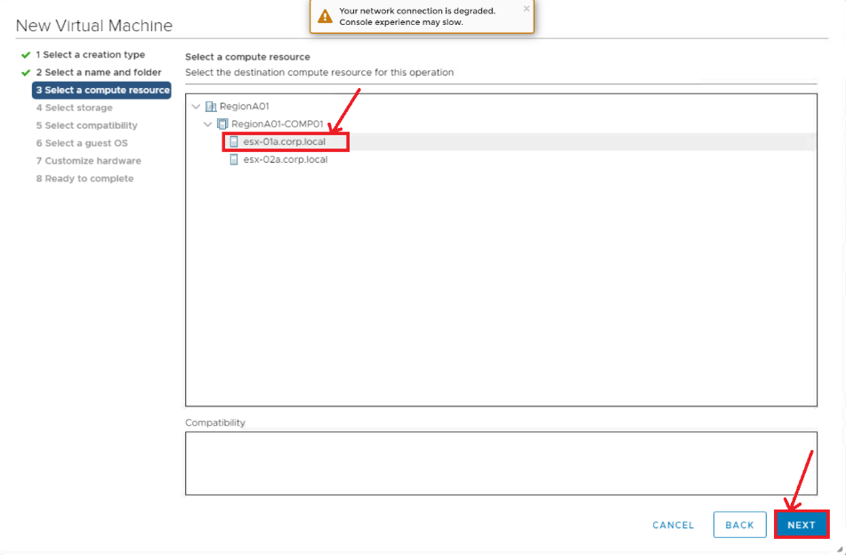

This is the interface for cloning and deploying VM from Template.

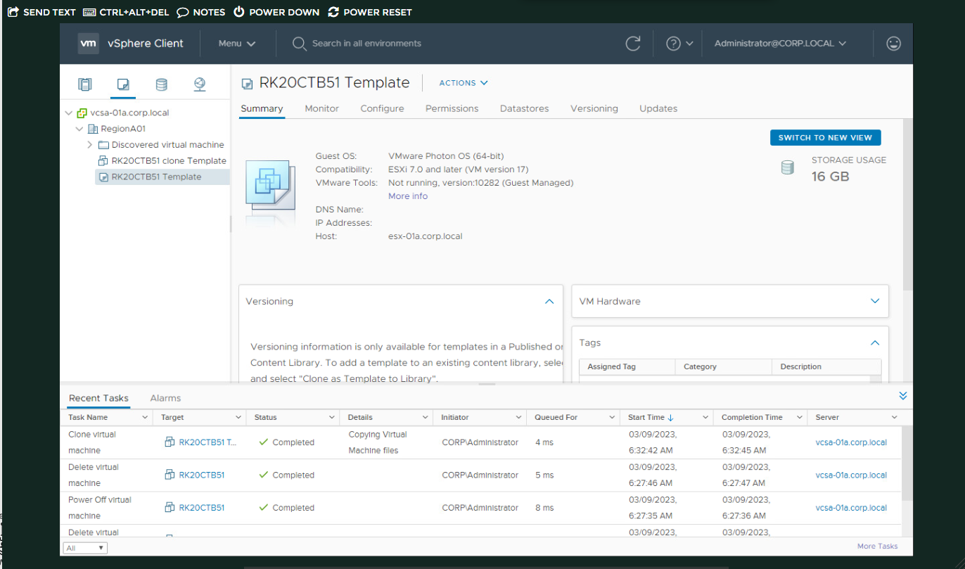

If there is no space in the disk cloud storage we need to delete the unwanted VM OS running in background.

**Task 3 : simulating the following**

Step 1 : Creating and editing alarms in vCenter Server

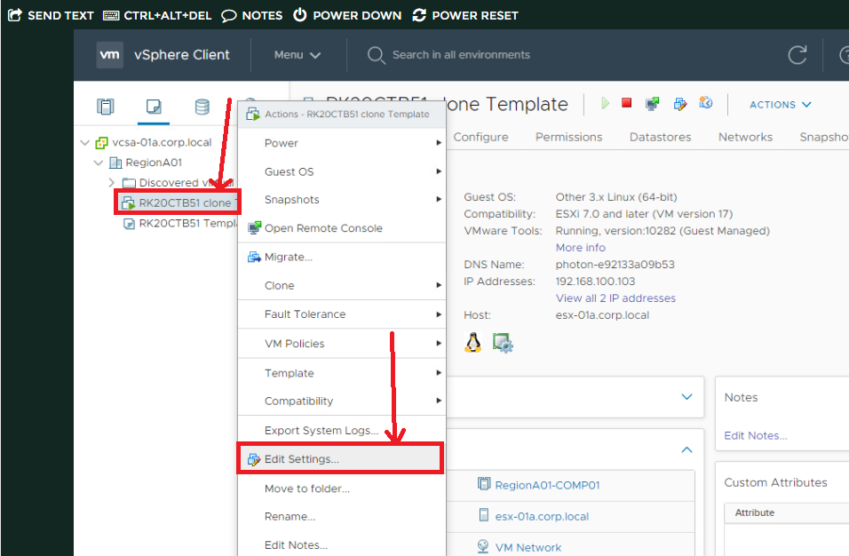

Check out the box of connect and click on OK.

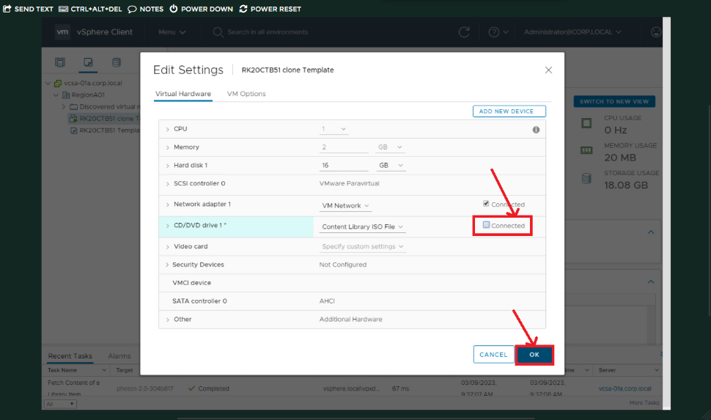

Click on Menu option and then select Events.

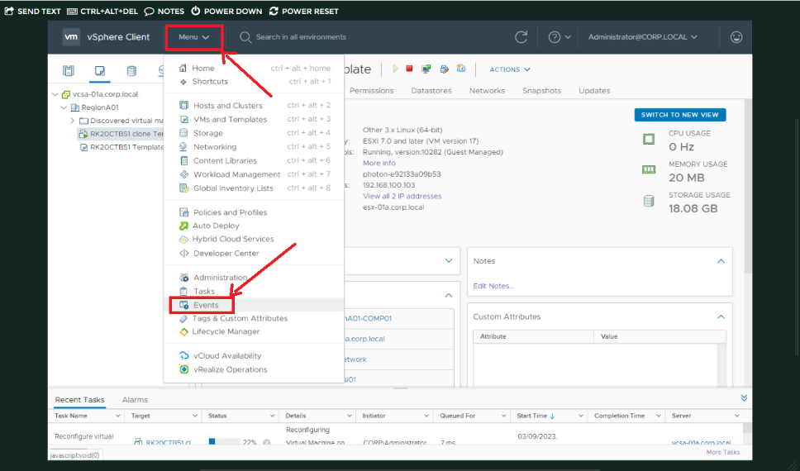

Now filter the date time manually.

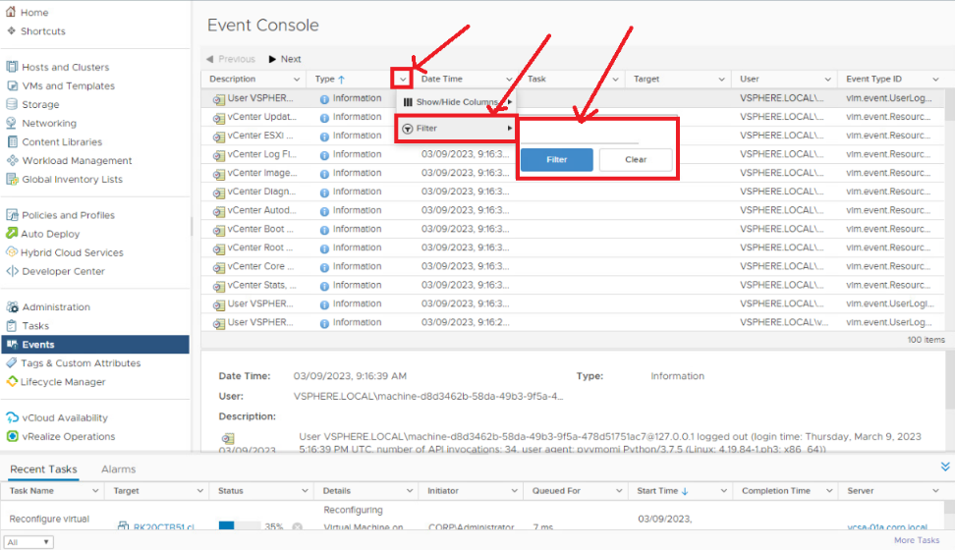

Clicking on Hosts and Clusters

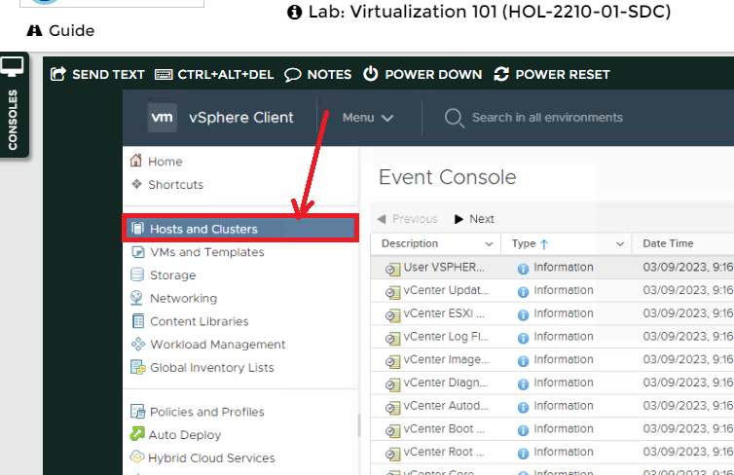

Choose the operating system vcsa-01a.local

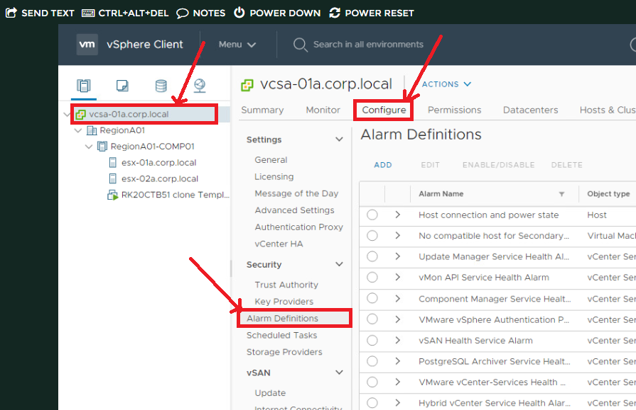

Choose Edit option and select any database.

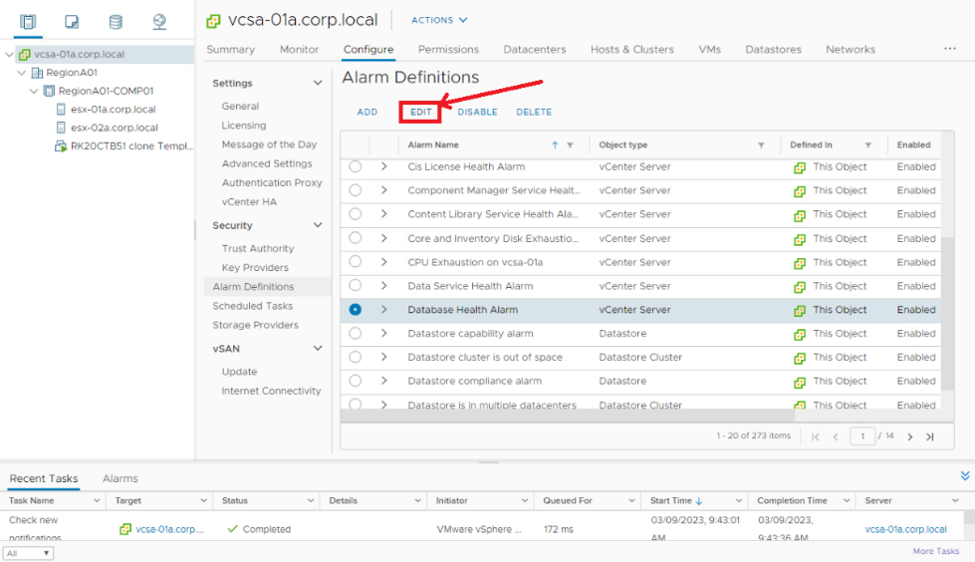

Change the target type and click on Next button.

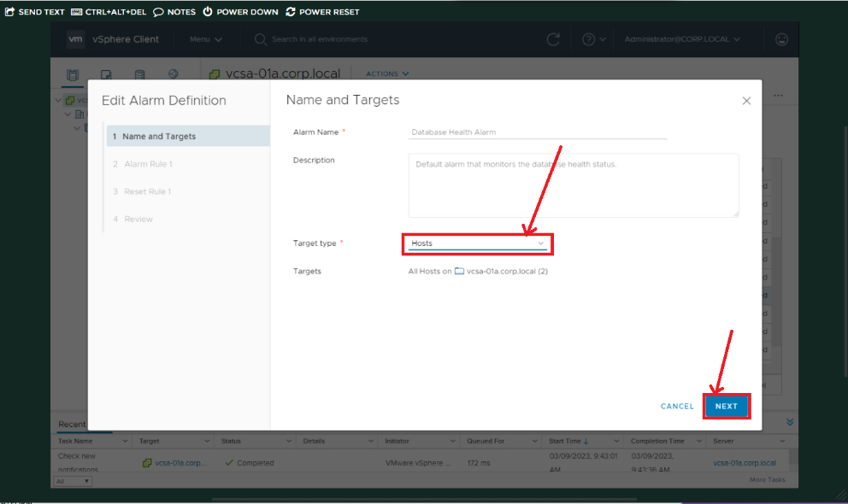

This is the rule 1 for Alarms. Select the Advanced Actions and click on Next.

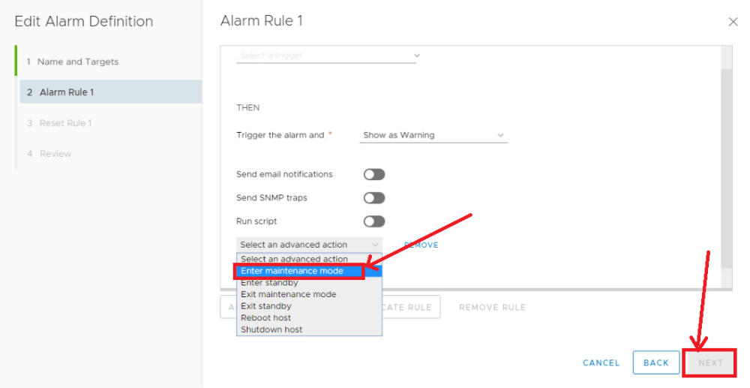

Choose the reset rule to green option which is already selected. Clicking on Next button.

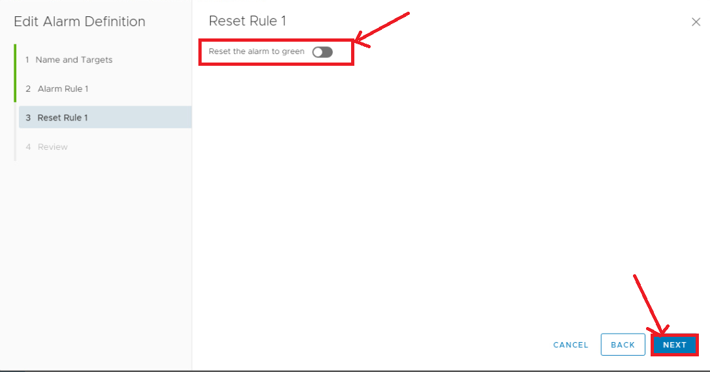

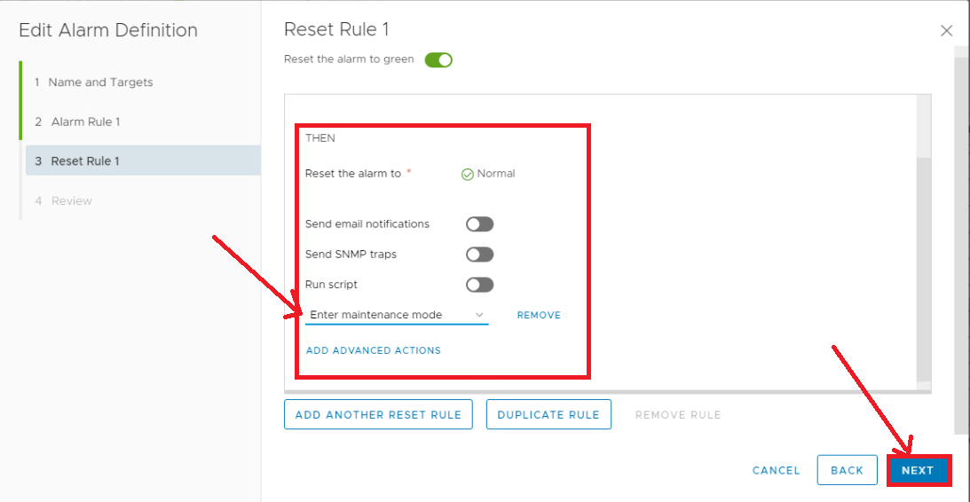

If needed change the alarm definition.

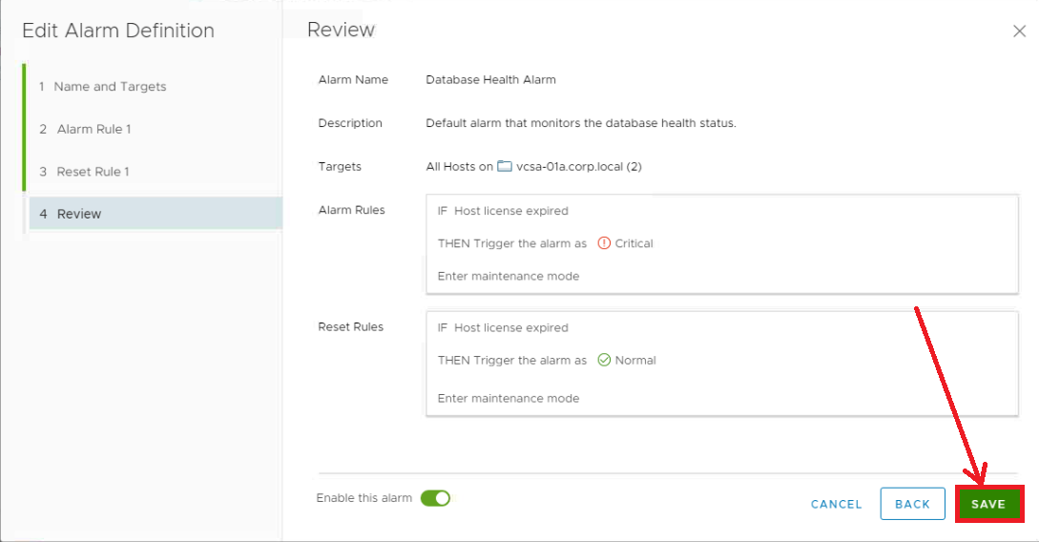

Click on Add Button by seeing the transfortion.

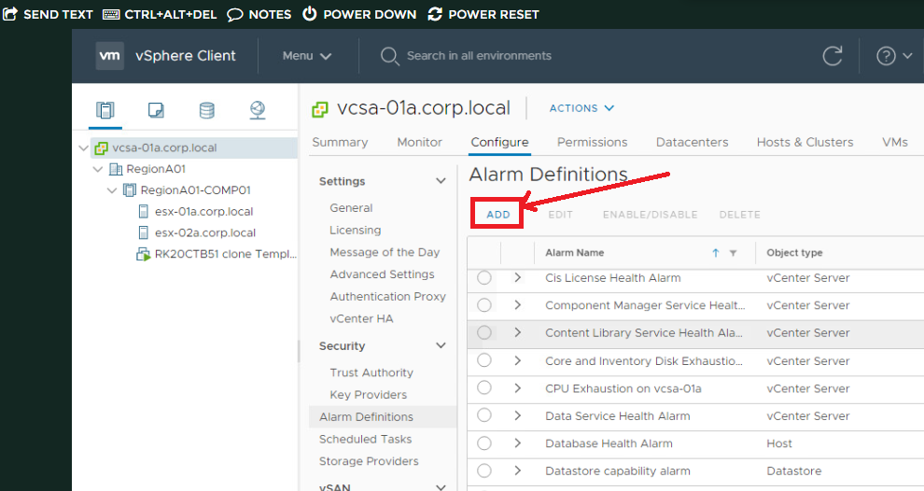

Select the name and Alarms

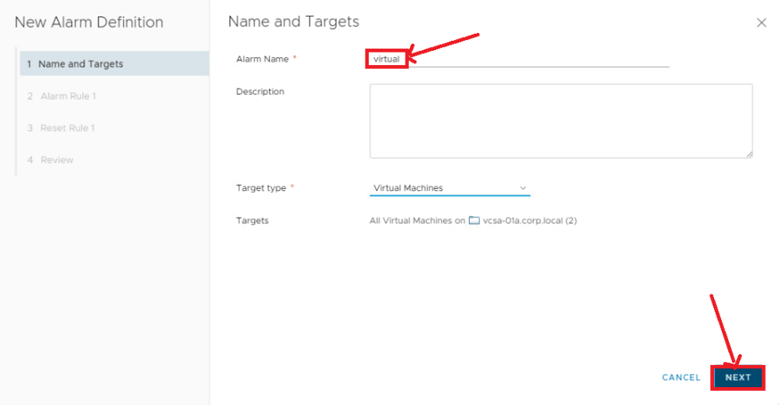

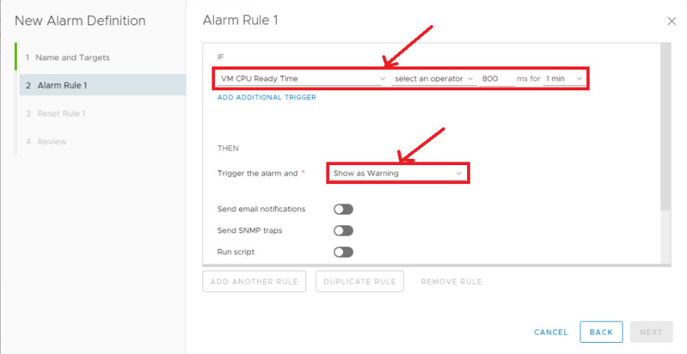

Simply click on Next.

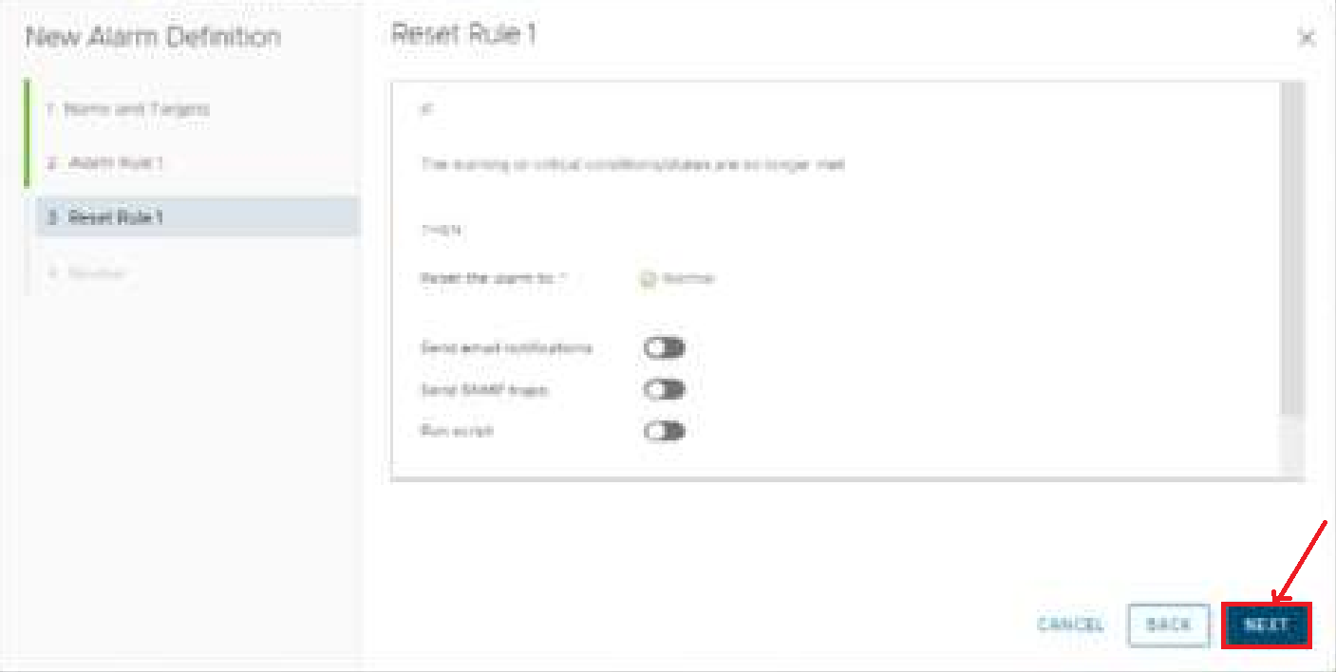

Here we are in the neighbour helpness.

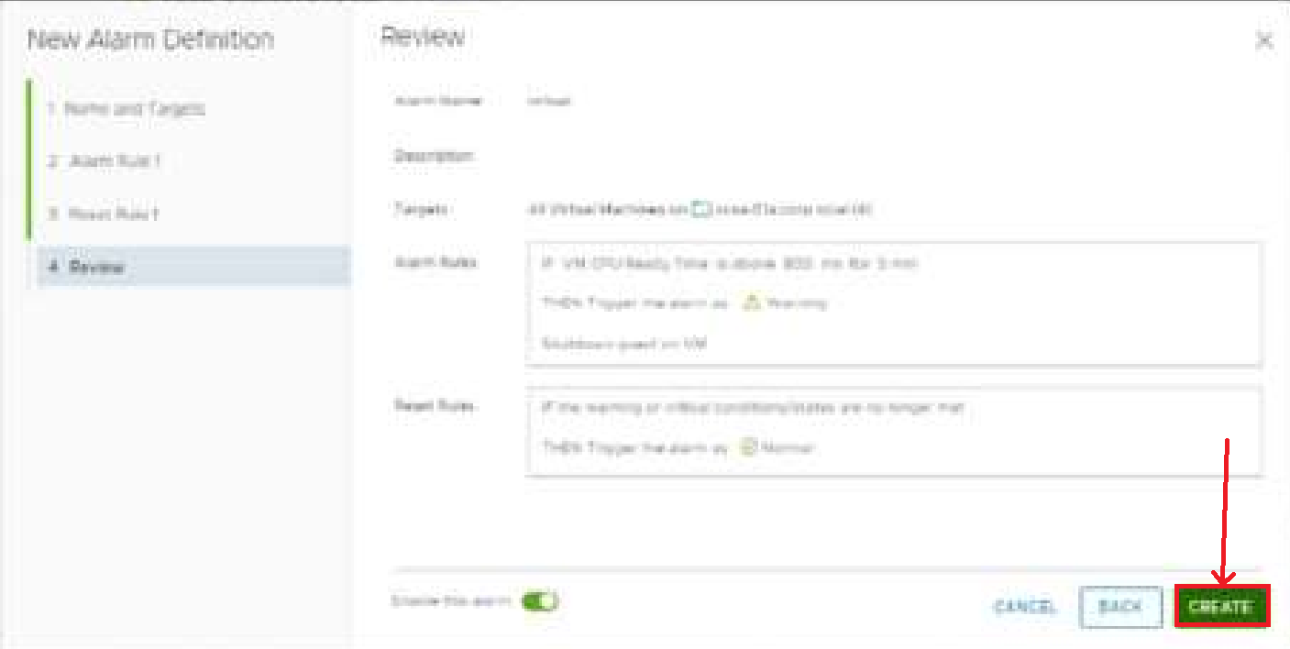

This is the last step to complete the steps for alarm

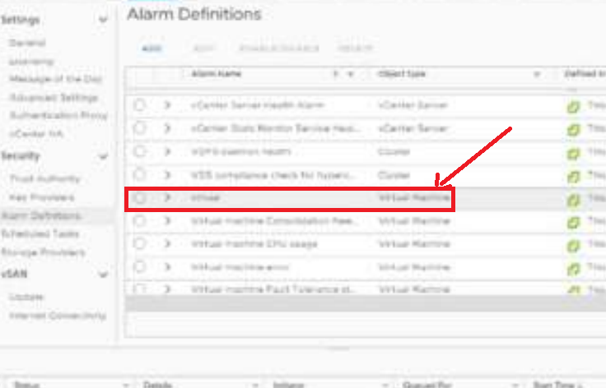

Step 2: Migrating VMs using VMware Motion

Right click on Esx-02. Than click on Add Networking option.

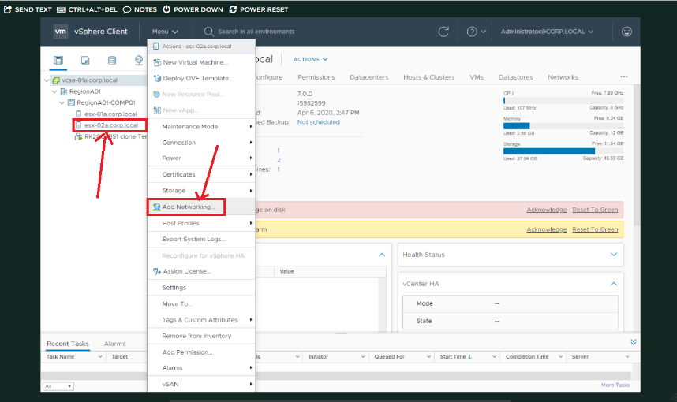

Select the Virtual Machine port and than click on Next button.

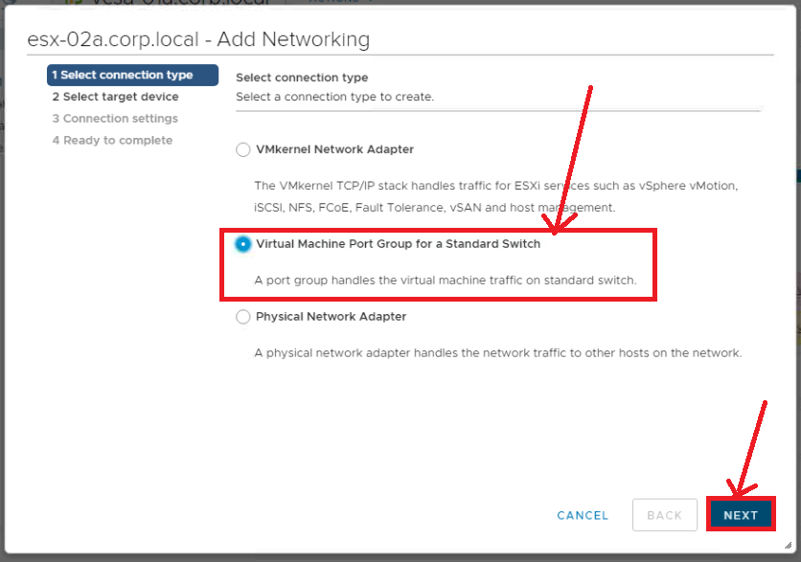

Select the New standard switch .and than click on Next.

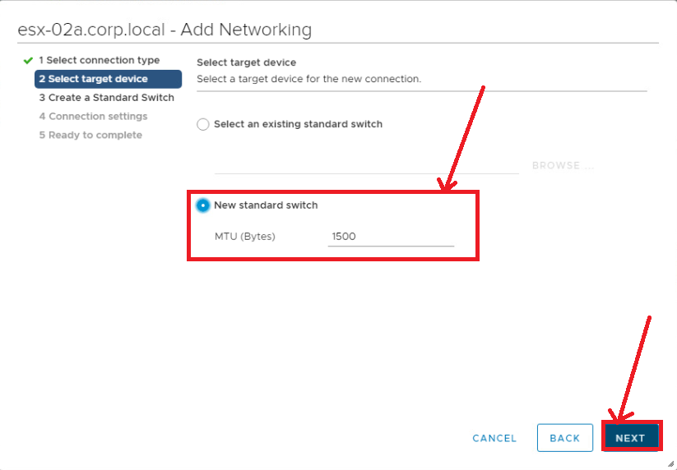

Select Unused adapters. Than click on Next.

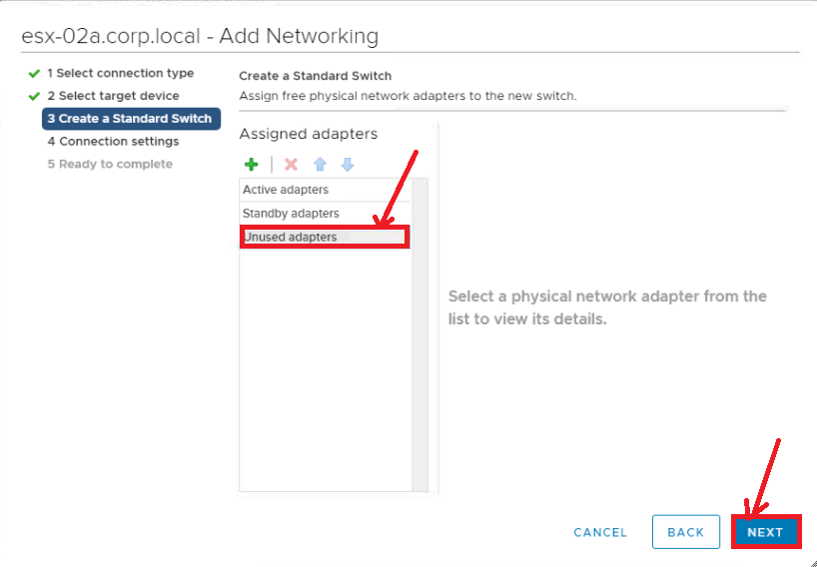

Simply click on Next.

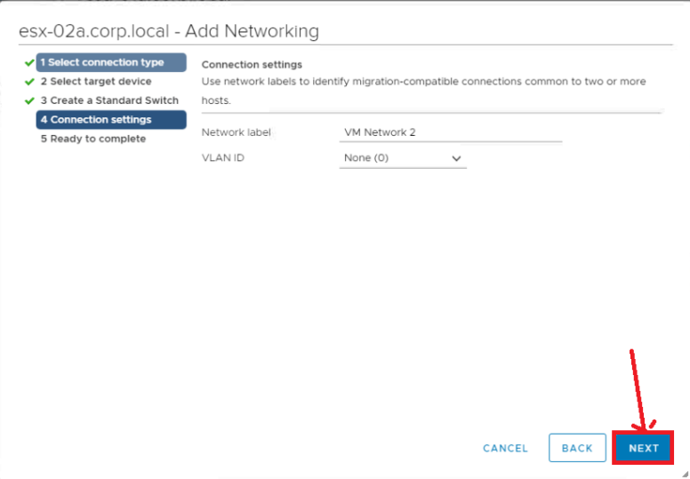

Now click on Finish and move forward.

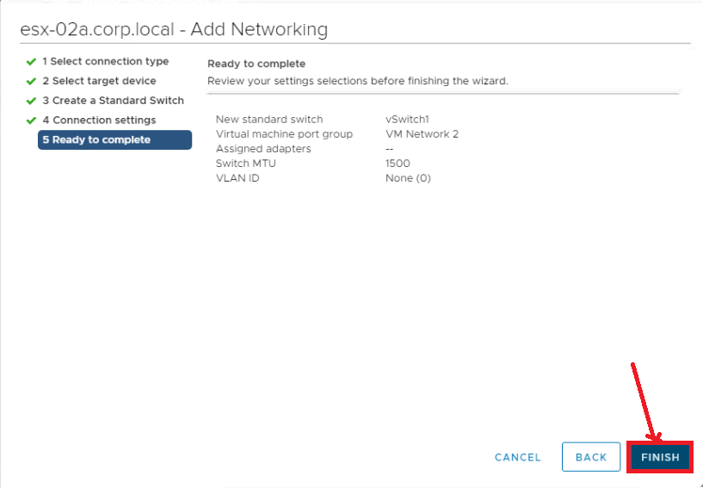

Firstly, Click on esx-02a and than click on configure option and than click on Virtual Switches

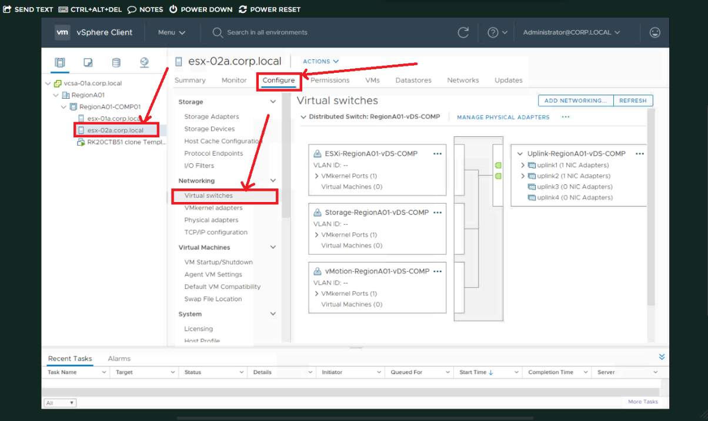

Clicking on esx-01a configure. Than virtual switches and choose Standard switch vswitch 0

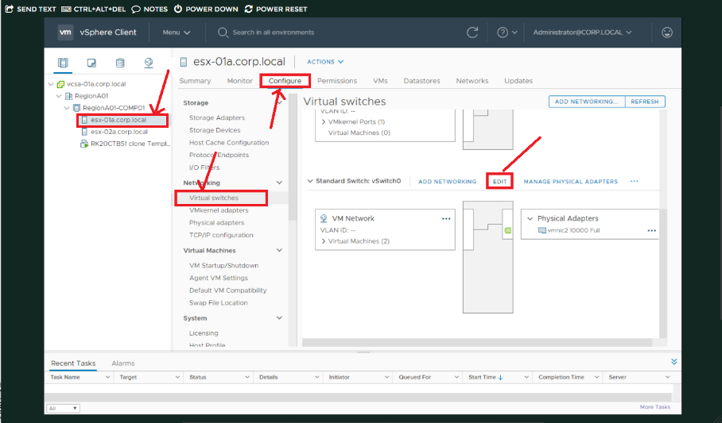

Clicking on Add Networking and than Select Physical Network Adapter. Click on Next

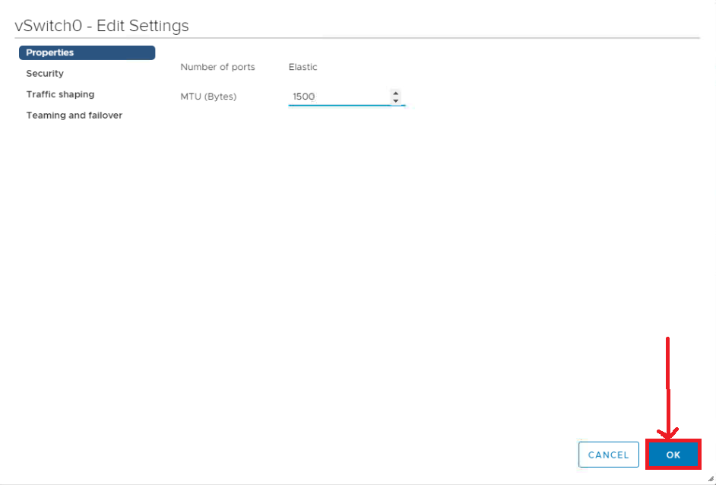

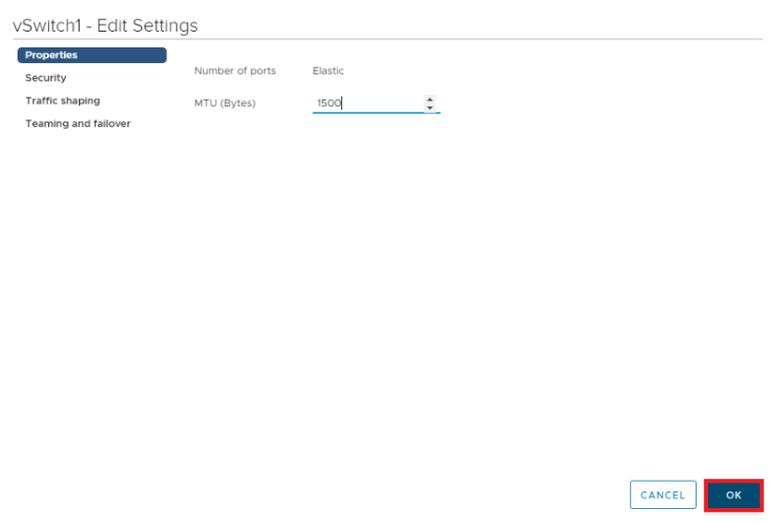

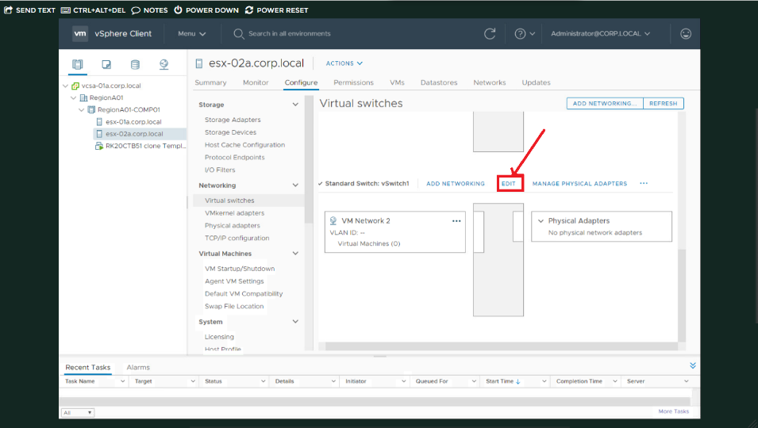

Click on OK.

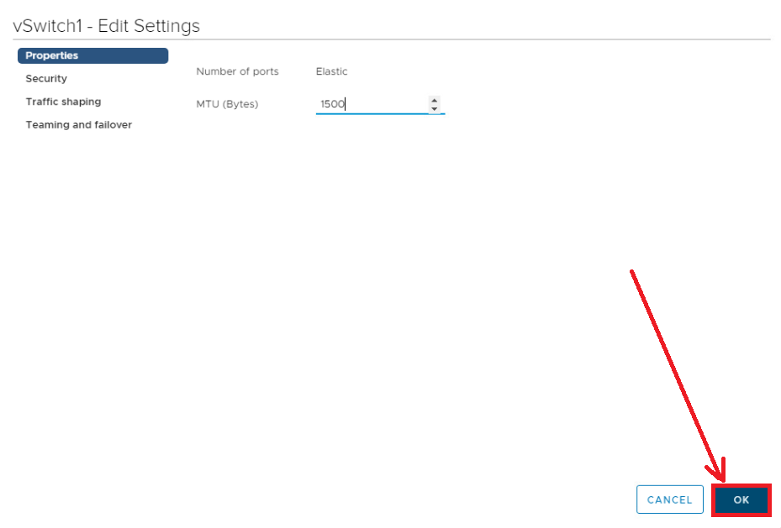

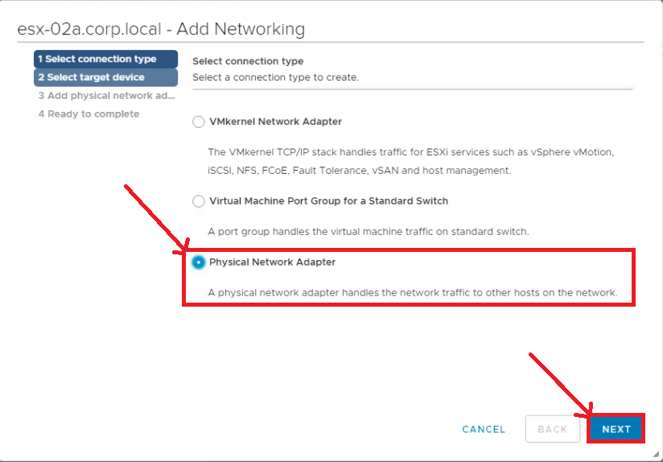

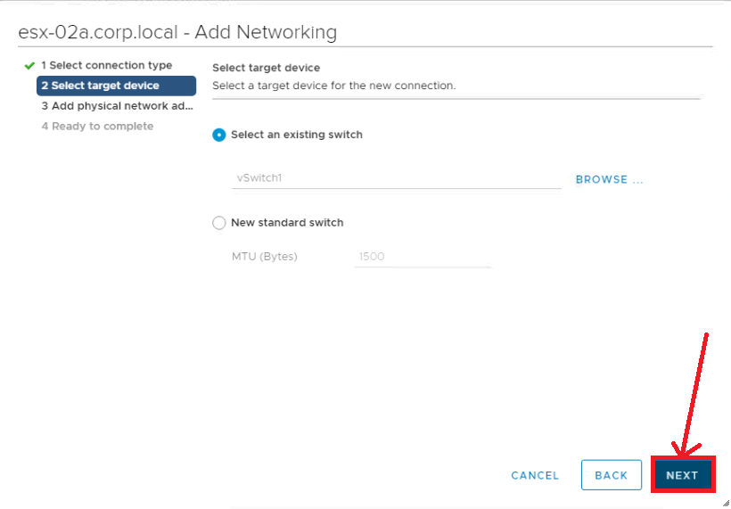

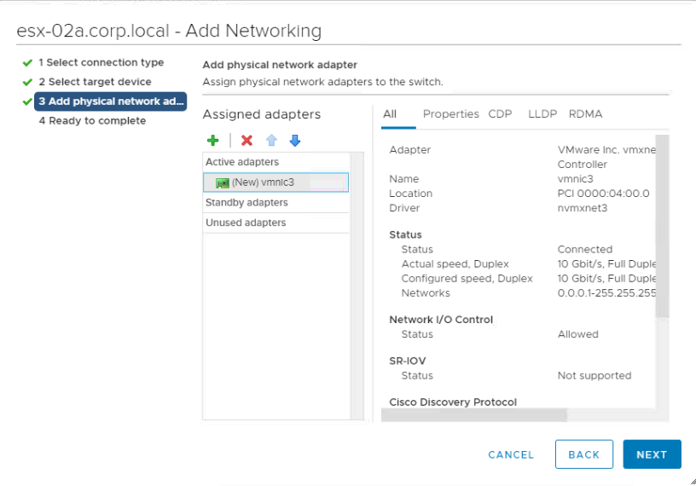

**Step 3: vSphere Monitoring and performance**

Firstly, Click on the Region A01 than Configure and development. Click on Edit.

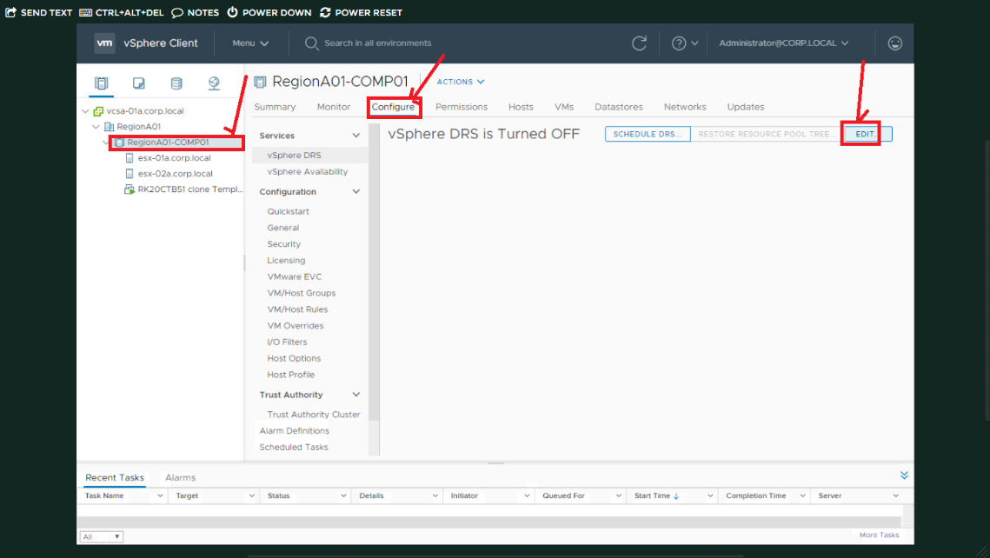

Select the VMs in which click on Select all VM. Right click on it and migrate option.

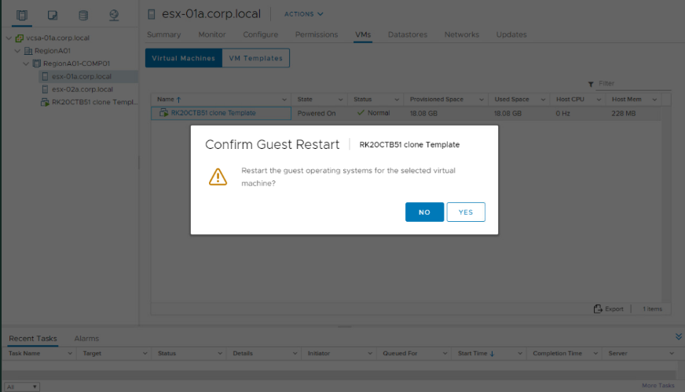

Click on yes.

Click on Next button

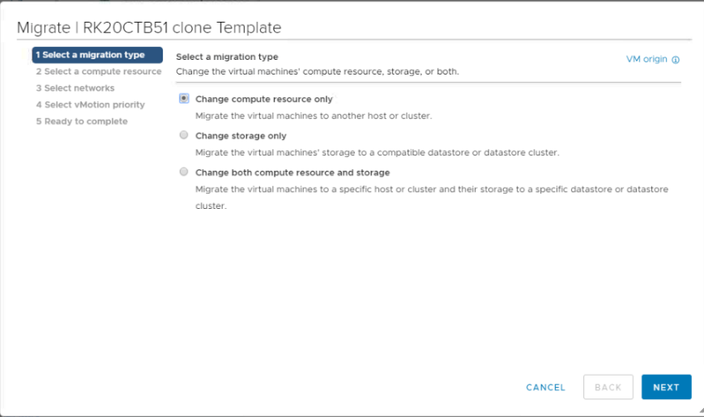

Click on Next option. After selecting esx-01a.corm.local.

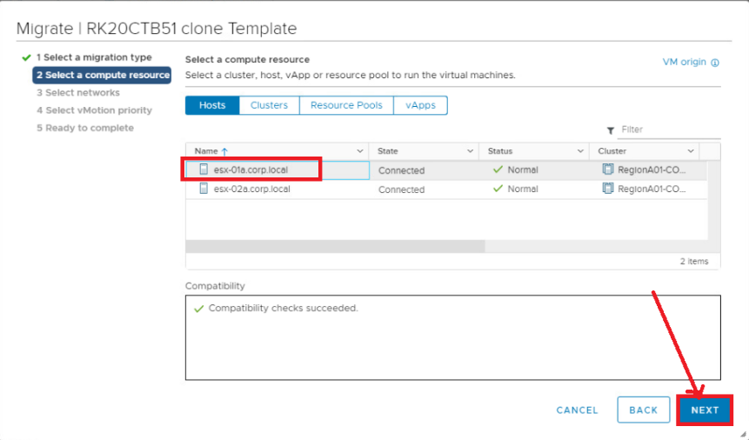

Click on Next button after checking the requirements and details.

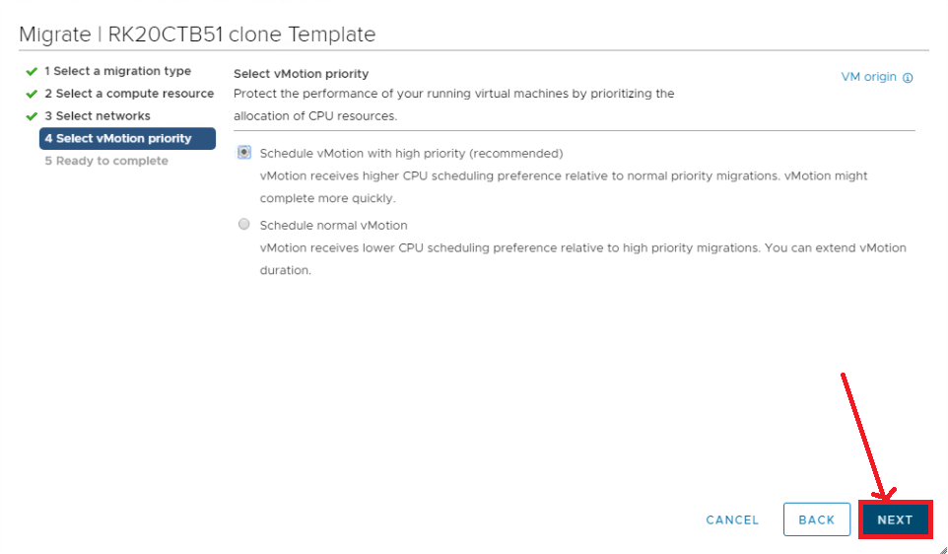

Click on Finish button.

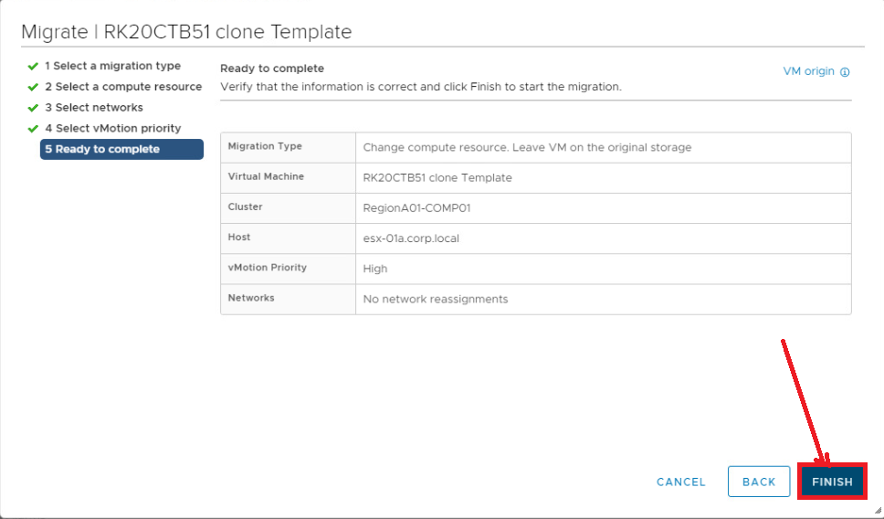

Go to the step Select esx01a,then choose Monitor. In that Select Overview and Real-time along with Select view as Virtual Machines

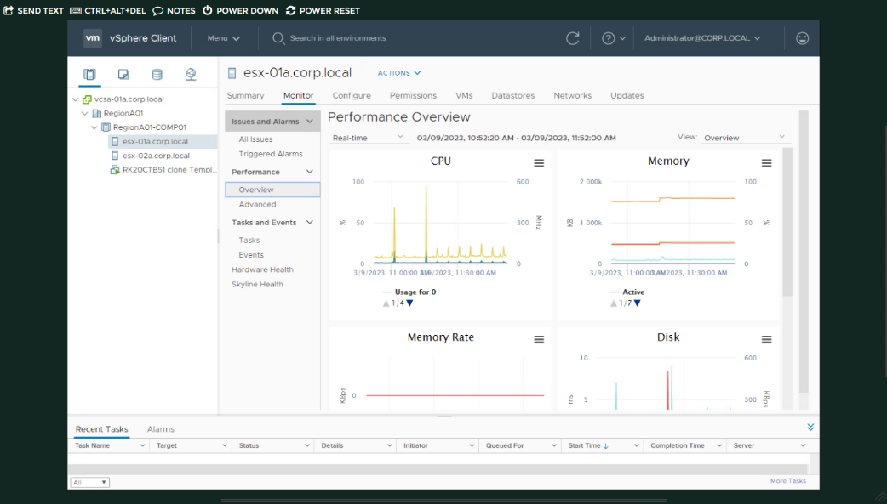

Now, Select esx-01a. From that Select all VM. Do Right Click and choose Power and Restart Guest OS

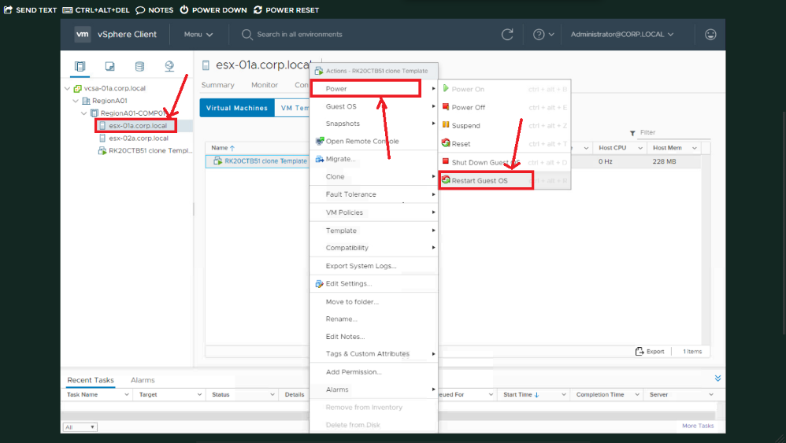

Click on Yes

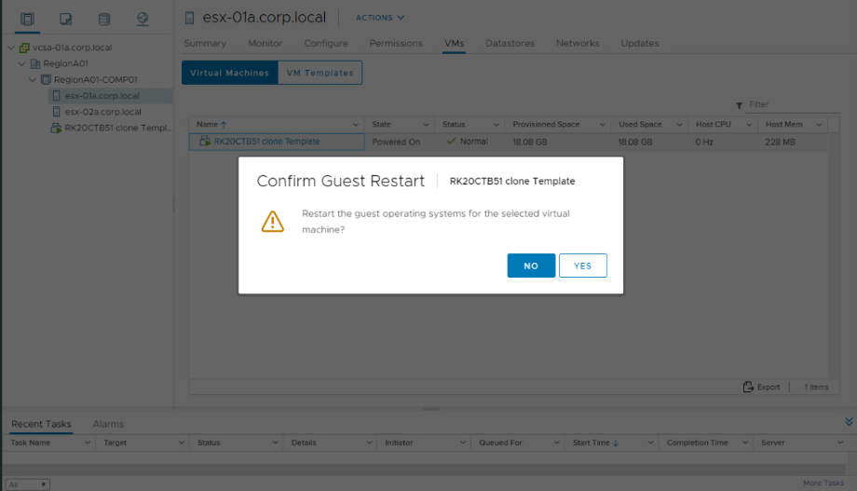

Select esx-01a to choose Monitor. Than Select Chart Options. In that choose Memory and Select all counters and at last click on OK.

